Card Board Challenge



intent:
Address potential fears, acknowledge personal strengths, and work creatively to build with cardboard.

OUTCOMES: Participants watch the Cain story, think of a personal strength, and use materials to build a creative game with cardboard.


Materials Required:
- PowerPoint
- Cain Video
- Cardboard materials (paper towel tubes, boxes, bags, scrap paper, bottle tops, egg cartons, etc.)
- Markers
- Tape, rubber bands, etc.

Time: 40 minutes

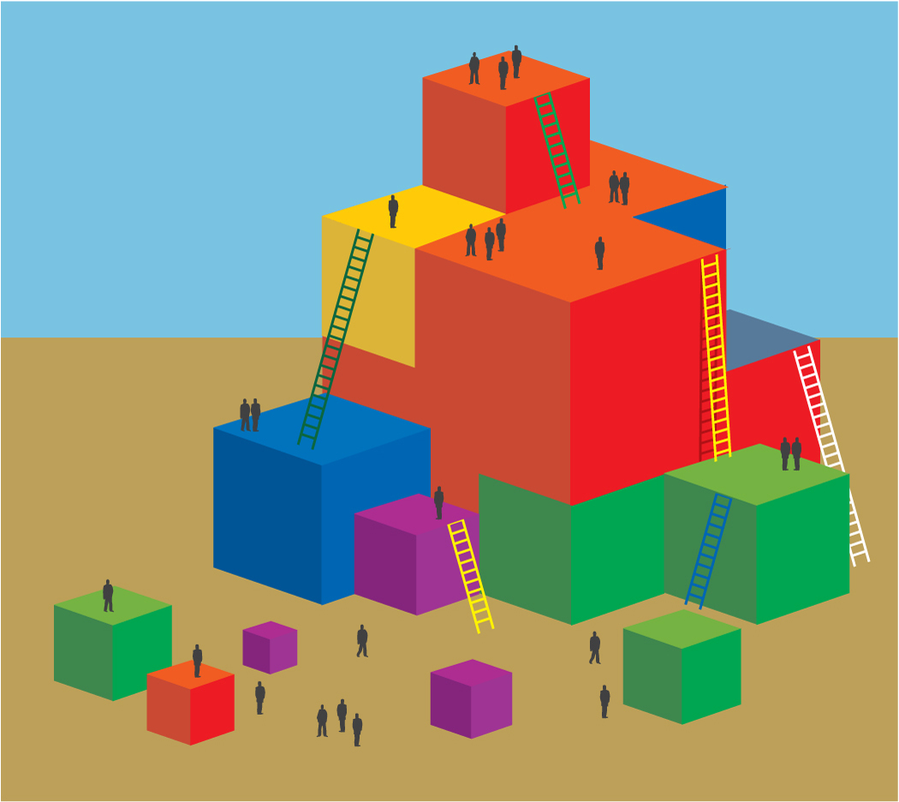
Process:
- Introduce the CAIN video. (Use notes on PPT.)
- Show the video. Highlight the creativity and motivation to learn displayed in the video.
- Invite participants to get materials from the table.
- Once participants have materials, say, “Look back at the list of concepts to foster in preschool science and consider your strengths. Do you ask a lot of questions/foster inquiry? Do you have a motivation to learn? Are you creative? You will pull from one or more of these strengths to be creative and build an arcade game. You can build your game on your own or you may work with your group.”
- Allow ample time to build the game. (20 min.).
- Tell participants, “Once you have completed your arcade game and practiced it a few times, bring it to the arcade. We will have an opportunity later to play the games.”
- After participants bring games to front, make a point to highlight a few of the strengths written on the boxes. These are the strengths of our room.

Debrief Options:
- Invite one or two people to demonstrate some of the more unique games or try them yourself with the trainers.
- Ask each group to demonstrate their game (if you have a smaller group).
- Ask each group to share one aha moment they had while creating their game.
- Ask each group to highlight science concepts used in their game.
- Ask each group to highlight the strength they pulled from to create their game.

SUMMARY:
Participants experience physical science concepts and build community while acknowledging a personal strength and building an arcade game with cardboard.

