Daily Data



**intent:**

Begin thinking about math in the classroom and experience different ways to support math reasoning through graphing.

**OUTCOMES:**

Participants will contribute to a welcome activity that involves math and will connect that activity to math concepts presented throughout the training.

MCBS00539A0000[1]**Materials Required:**

* 2-3 Daily Data charts (see example below)
  + Facilitator can make up own questions - try to have at least two different types of charts (e.g., Venn diagram and t-chart).
* Dancing ClockPPT Notes
* Handout 1: Taking It Back to the Classroom

**Time:** 10 minutes total

(5 minutes at the beginning of day and 5 minutes near closing)

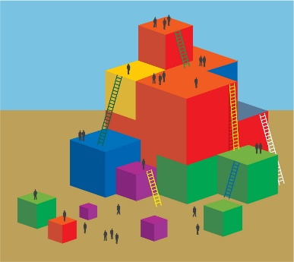**Process:**

* Prior to the training:
  + Put 2-3 daily data charts up in the room. Examples:
    - A Venn Diagram with two circles overlapping: “I love math and can’t wait to learn more!” vs. “Math is my least favorite and I am scared you will give us a test today.”
    - A t-chart with the title “I do more…” and two columns labeled “math songs” and “math stories.”
    - A bar graph with numbers on the “Y” axis and the following four strands on the “X” axis: Numbers Sense, Geometry, Algebra and Function, and Measurement. Title the bar graph “Rate Your Ability in Each.”
* Begin the activity:
  + Welcome participants as they enter and ask them to put their responses on the charts. Point out the slide being projected with the directions.
  + Wander the room supporting conversation as participants provide their daily data.
* Debrief:
  + Say, “Let’s see what our daily data tells us.” Potential information:
    - Our bias towards math
    - Our strengths in math
* Highlight that we are focusing on math reasoning; this means that we are looking all math content areas and can capitalize on any and all of our math strengths.
  + - Point out the variety of responses (if there is variety) and emphasize that participants can use each other to expand their ideas.
  + Ask participants how they currently use charts and or graphs in the classroom.
  + Say, “Throughout the day we will deepen our understanding of math reasoning as it pertains to the Preschool Learning Foundations. Remember to think about how you may want to add graphs like those we just created to support this development in your classroom.”