Writing Measure





**intent:** Examine the developmental levels on the Emergent Writing measure.

**GOAL:** Place the terms, descriptors, and work samples created by participants in a developmental sequence that matches the DRDP-K (2015) measure page.

**Materials Required:**

* MCBS00539A0000[1]PowerPoint slides
* Handout 4: DRDP Measure LLD 10
* One envelope with developmental level labels, descriptors cards, and eight blank ¼ sheets of paper
* Play-Doh
* Toothpicks that participants can choose to use while creating their writing samples
* Paintbrushes of all shapes and sizes
* Markers
* Chalk
* Crayons
* Finger paint

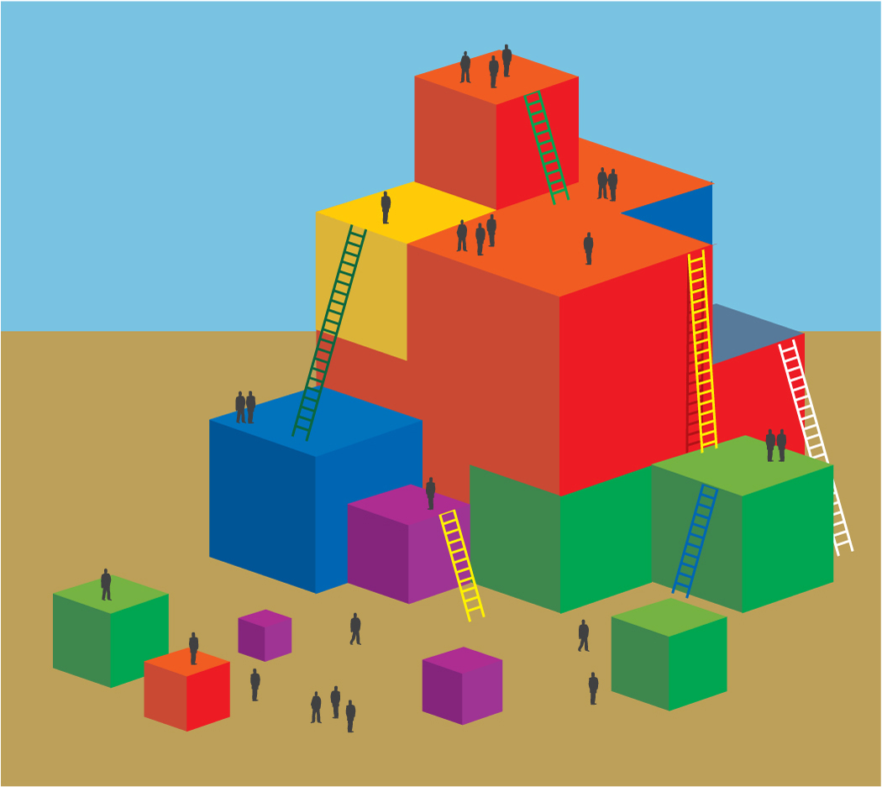**Time:** 10 minutes

**activity Process**

1. Show slide with the measure page.
2. Participants silently read the entire measure page carefully.
3. Show slide with directions while participants retrieve the envelope with developmental level labels, descriptors, and blank paper; hold up envelope for participants to view.
4. Have participants pour out the contents of the envelope and choose a developmental level card and a blank piece of paper.
5. Ask participants to use the measure page to reread the descriptor and examples for the developmental level card they have chosen.
6. Direct participants to create a work sample that would match their descriptor; have them stand up when finished.
7. When all tables are done, they will exchange their work sample with another table.
8. Ask participants to recreate the DRDP-K Measure page by matching the developmental level for the descriptor to the work sample they were given. Remind them it is a left to right continuum.
9. Move around the tables to see if things are being laid out in a left to right progression.
10. Ask participants to sit down when finished.

Reflection:

* Return to the large group.
* Direct participants to review the measure’s developmental level labels, descriptors, and examples again. Ask volunteers to discuss what clues they used to help determine the developmental sequence.

MCj02958800000[1]

**OPTIONS:**

1. If more than six people at a table, two people could each create a work sample for the same developmental level.
2. Use raffle tickets as an incentive for the table that finishes first.