Build A Bridge



intent:
Build and engineer a bridge while considering the properties, characteristics, and changes in nonliving objects and materials.

OUTCOMES:
Participants explore the size, shape, weight, texture of objects as well as form, function, cause and effect, force, stability, motion, and changes in objects and materials.



Materials Required:
- PowerPoint
- Handout 6A: Build a Bridge Recorder Handout
- Handout 6B: Build a Bridge Reflection Handout
- Styrofoam packing peanuts
- A small cup of water per group
- Boxes of tooth picks per group
- Three tennis balls per group
- Two chairs per group

Time: 25 minutes

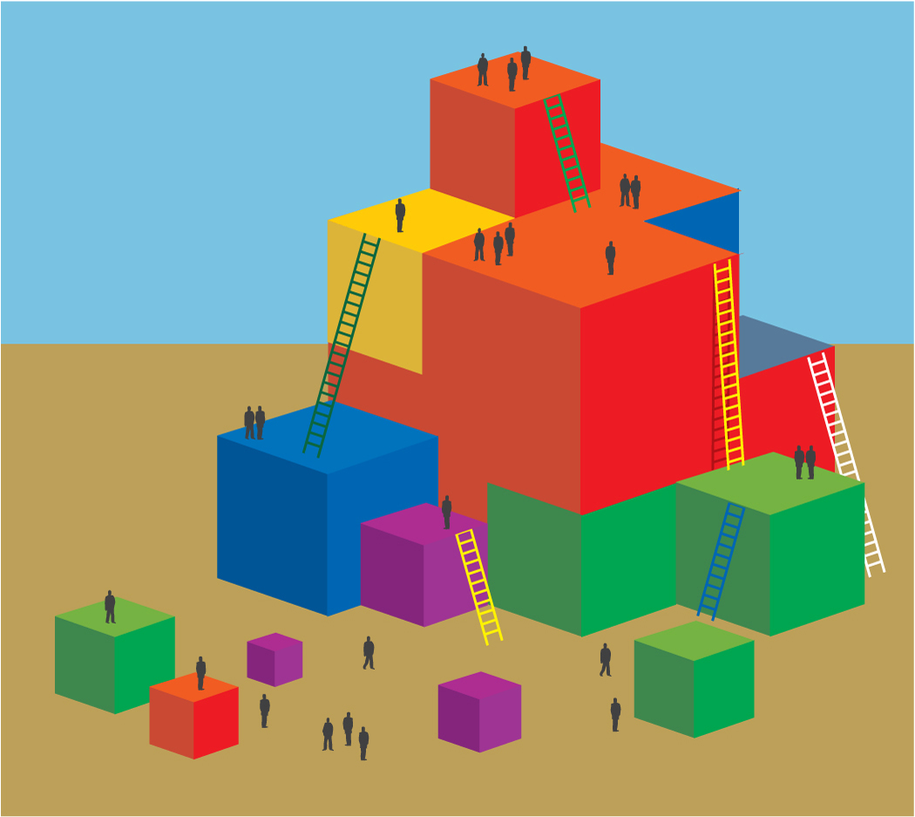
Process:
- Participants form groups of 3-4 people. Large table groups should be divided in to two smaller groups.
- Ask groups to identify a recorder for the activity.
- Explain that participants will construct a bridge using Styrofoam packing peanuts over the back of two chairs. The bridge should be strong enough to hold three tennis balls.
- Each group will place two chairs back-to-back about 4-5 inches apart and begin building the bridge.
- They can use as many and ONLY Styrofoam packing peanuts and toothpicks. Water can be used to help Styrofoam peanuts stick together.
- The recorder records and documents the activity using Handout 6A.
- After 20 minutes, ask groups to share their experience and how they used physical science and scientific inquiry skills to build and engineer their bridge.

