Experiencing Universal Design for Learning: Geometry



**intent:**

Introduce the concepts of Universal Design for Learning (UDL) in teaching and learning.

**OUTCOMES:**

Participants experience how to engage, express, and represent information in multiple means through a simple teaching/learning activity. They explore how UDL principles support unique learning needs through the design of environments, materials, and teaching strategies.

**Materials Required:**

* MCBS00539A0000[1]PowerPoint slide
* Dancing ClockHandout 8: UDL Circle
* Pencil
* Blank pieces of paper
* OPTIONAL: Display of common materials that could be used to teach about circles and roundness (hoops, rings, string, jump ropes, bubble soap, balls, paper/markers, sand trays, etc.) with a multisensory approach.

**Time:** 15 minutes

**Process:**

1. 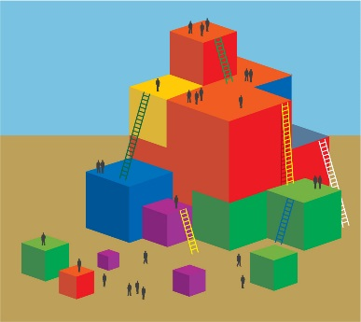Trainer sets the stage by saying, “Let’s pretend that I am the teacher and I have decided to teach you all to identify a circle.” (The circle will appear on the second click.) As the circle appears, the trainer continues by saying, in a comical manner, “Children, this is a circle!” Ask a few audience members, “What is this?” and elicit the response, “A circle.”
2. Trainer transitions by saying “We will now focus on circles through the lens of Universal Design for Learning.”
3. Ask participants to find examples of circles around the room. Invite them to demonstrate “circles” with the four prompts on Handout 8: UDL Circle (draw one, find one, make one, show me).
4. Using Handout 8, participants brainstorm with the materials displayed to see how many ways they can think of to draw, find, make, or show a circle.
5. Invite each table group to take notes for a share-out.
6. Lead a brief discussion to collectively brainstorm various ways that children can use the four prompts in the handout to engage with circles.
7. With the entire group, focus on children with special needs. How might a teacher gather information about circles from children with each of the following:

* Hearing impairment?
* Vision impairment?
* Physical challenges?

MCj02958800000[1]**OPTIONS:**

* Instead of inviting all participants to demonstrate the activity, have trainers act out the activity in front of the group.
* Instead of using a circle, use domain-related content to complete the activity. For example, use the idea of throwing a ball for physical development, or use a letter for writing.
* After the circle lesson, connect back to the foundations by asking participants to identify domains that could be addressed through this activity (e.g., math, literacy, social-emotional, physical development).