Science Language Challenge |  | 
 | intent:  Teach participants science vocabulary and provide movement breaks throughout the training.

OUTCOMES:

Participants build community with each other, gain familiarity with science vocabulary, and experience the connection between movements, art, and science.
 | Materials Required:  PPT slide  Trainer notes  Sticks with vocabulary words written on them  Container for the sticks (pencil jar, mason jar, plastic cup, etc.)  Preschool Learning Foundations glossary for support  Handout 11: Glossary  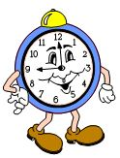  Markers, crayons, etc.  Scratch paper  Time: 30 minutes (broken up throughout the day)  10 min., 5 min., 5 min., 5 min., 5 min.
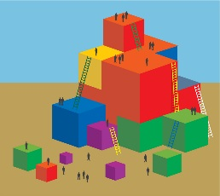 | PROCESS:  Each table group must identify a science vocabulary word (one per table group):  - One player from each table group is labeled the “scientist.” The “scientist” pulls a vocabulary stick. Each stick has a word on it. The “scientist” must keep the stick hidden from their tablemates.  - Trainer rolls the die and announces what it lands on (verbalize, dramatize, or picturize).  - Verbalize: This indicates that the “scientist” will describe the word without actually saying the word or any parts of it (similar to Catch Phrase!).  - Dramatize: This indicates the “scientist” will act out the word and provide clues through dramatization (similar to charades).  - Picturize: This indicates the “scientist” will draw clues for the group to guess the word (similar to Pictionary).  - Each “scientist” must provide clues to their table group to help them guess the word by using the technique specified by the die cast.  - When a table group has correctly identified the vocabulary word the entire table group stands up and says, “Complete.” The table that shouts “Complete” first is the winner.  - Trainer turns the timer over and says, “Language challenge on!”  - Trainer congratulates the winning table and asks the remaining “scientists” to tell their table groups what their vocabulary word was.  - Trainer asks all participants to find the definition of the word they were just guessing on the science glossary handout. Participants can add anything to the description that they think would be helpful to them.  - Throughout the day the trainer can replay this game by stopping and saying, “Time for a language challenge!” Simply have each table group identify a new “scientist,” pull a new vocabulary stick, and roll the die again for each new round.
 | SUMMARY:  Participants learn science vocabulary through an interactive guessing game.

