Language of Logic and Reasoning



**intent:**

Become familiar with vocabulary and questions that support mathematical reasoning across the Mathematics strands.

**OUTCOMES:**

Participants will gain a greater understanding of the types of questions and vocabulary used to support children’s mathematical reasoning.

MCBS00539A0000[1]**Materials Required:**

* + - * PPT notes
      * Handout 7: Language of Logic and Reasoning
      * PPT slides
      * Sentence strips (1-2 per person)
      * Dancing ClockDark marker (1 per person)
      * Highlighters
      * Sign for grouping people (Part 2 of activity)

**Time:** 15 minutes

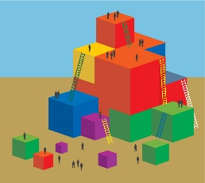**Process:**

Part 1

* Direct participants to Handout 7: Language of Logic and Reasoning.
* Use echo reading, or another group reading strategy, to read through the handout.
* Direct participants to highlight one thing in each section that is of interest to them.
* Ask participants write one question on a sentence strip to take home to their classrooms.

PART 2

* Have one participant from each table group either leave the room or close their eyes. These participants will be the “observers.”
* Hold up a sign by which the remaining participants will self-sort. For example, the sign might read:
  + Boys vs. Girls
  + Slip-on shoes vs. Non slip-on shoes
  + Wavy hair vs. Straight hair
* Direct participants to organize themselves without talking.
* Have “observers” return to the room (or open their eyes).
* Use a series of questions from Handout 7: Language of Logic and Reasoning to guide a discussion with the “observers” until they come up with the correct answer as to how the groups are sorted.

**OPTION:**

* Rearrange the group into a pattern and repeat the process using the information from Handout 7: Language of Logic and Reasoning.
* Ask two-three table groups to pair up and repeat the activity with another attribute. One person will become the “facilitator,” some group members will represent the “data,” and the others group members will be the “observers.”