“Family Fun Night” Blueprint



**intent:**

Incorporate the information learned in the presentation to design a blueprint for a “Family Fun Night” that staff/parents/volunteers can create with TK children and families.

**OUTCOMES:**

Participants will review information from the presentation and cooperatively design a blueprint for a “Family Fun Night” that is appropriate for TK children and families.

MCBS00539A0000[1]**Materials Required:**

* Participants’ notes from the presentation
* Chart Paper (1 per table) and markers
* Handouts used during presentation
* OPTIONAL: Yarn balls, bean bags, beach balls, pool noodles, scarves, jump ropes, or other materials to enhance activity



**Time:** 20-30 minutes (depending on the size of group). Tables have 20 minutes to design an activity and share their blueprint (chart paper) with one or two other tables.

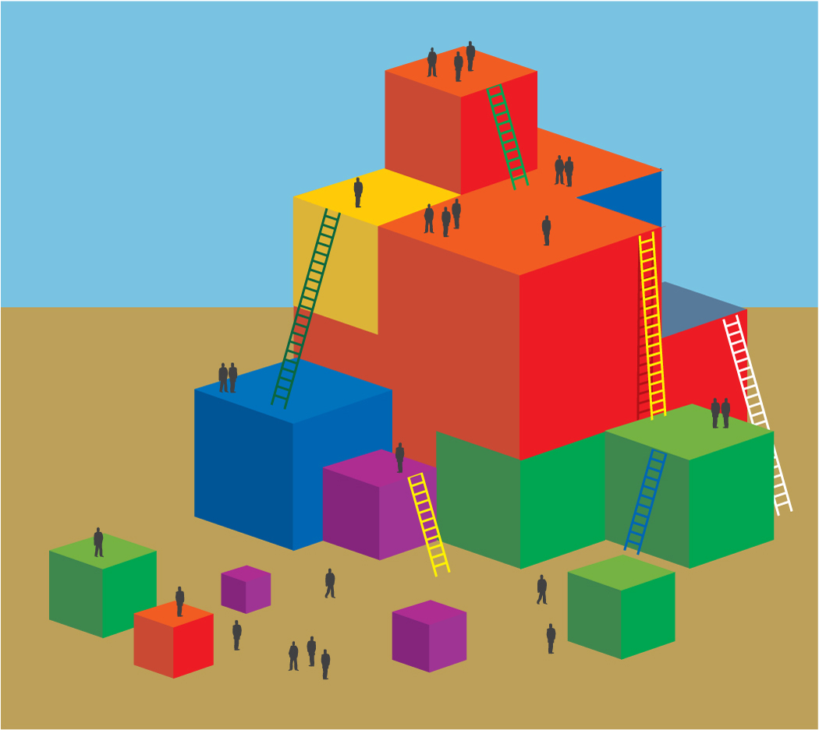 **Process:**

* Activity prompts and directions:
  + Review the handouts used throughout the presentation.
  + Work with your tablemates to cooperatively design a “Family Fun Night” blueprint. The blue print must include an introduction, multiple stations, and a conclusion that is inclusive of all fundamental movement skills.
  + Prepare to share-out your blueprint with one or two other table groups.

**OPTIONS:**

* Participants should consider and apply accommodations for children with disabilities and strategies for English-language development.
* Groups can set up a small version of stations for demonstration purposes.
* Encourage groups to integrate content areas (Math, Science, Language and Literacy, etc.) to illustrate moving and learning through active physical play.