Taking it back to the Classroom



**intent:**

Create strategies on how to adapt a lesson plan for the classroom.

**OUTCOMES:**

Participants will:

* Make a puppet for the lesson
* Create strategies that involve math reasoning
* Use strategies to adapt lesson plan for their classroom

MCBS00539A0000[1]**Materials Required:**

* PPT Notes
* Handout 1: Taking It Back to the Classroom
* Large chart paper (1-2 per table)
* Materials table arranged with materials to create puppet:
  + Paper bags (puppet base)
  + Colorful markers
  + Paper bags to make puppet
  + Construction paper
  + Glue sticks
  + Yarn
  + Dancing ClockDecorative stickers
  + Buttons
  + Cloth or fabric
* Timer or bell

**TIME**: 30 minutes

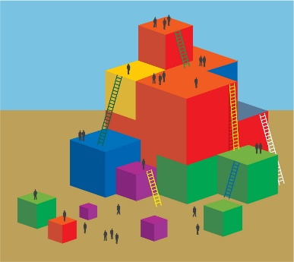

**Process:**

Part 1

* Direct participants to find and read Handout 1: Taking It Back to the Classroom. (Allow five minutes to read handout.)
* Explain to participants that they will now make their own puppet using the supplies provided on the materials table; have them grab a paper bag base and gather any other materials they would like to bring back to their table to use. (Allow five minutes to create puppet.)
* Ask participants to refer to the activity #2 – Mr. Fur Ball from Handout 1: Taking It Back to the Classroom.
* Have each table group work together to for 10 minutes create strategies to adapt the Mr. Fur Ball lesson plan to support the needs of the students in their classrooms. Remind groups to:
  + Consider children whose home language is something other than English
  + Consider children who may have IEPs or specified disabilities
  + Document their strategies on a large sheet of chart paper
* Ask each group to come to the front of the room to place their chart on the designated wall or area; they will then stay standing by their chart.

Part 2

* Explain that participants will now do a gallery walk to obtain more ideas from their peers. Moving in table groups, they will look at each chart for a specified amount of time (Divide the number of groups into 10 minutes to come up with how much time will be spent at each chart.) Each time the bell or timer rings, groups will proceed to the next chart, moving clockwise.
* Remind participants to read through the strategies on each chart and to discuss how those strategies may help them in their classrooms.
* Ring the bell or timer to begin the activity. (Groups move away from their own chart and proceed in a clockwise direction to the next chart.) (Allow 10 minutes to rotate through charts.)
* Bring the whole group back to their seats.