Activity 4: Developmental Sequence



**intent:**

Improve participants’ understanding of the counting developmental sequence.

**OUTCOME:**

Participants will practice identifying the counting developmental sequence.

**Materials Required:**

* MCBS00539A0000[1]Number line
* Dancing ClockPCF
* Handout 12: DRDP-K Measures
* Table materials:
  + - Developmental Sequence Envelope
    - Developmental Sequence Cards

**Time:** 10 minutes

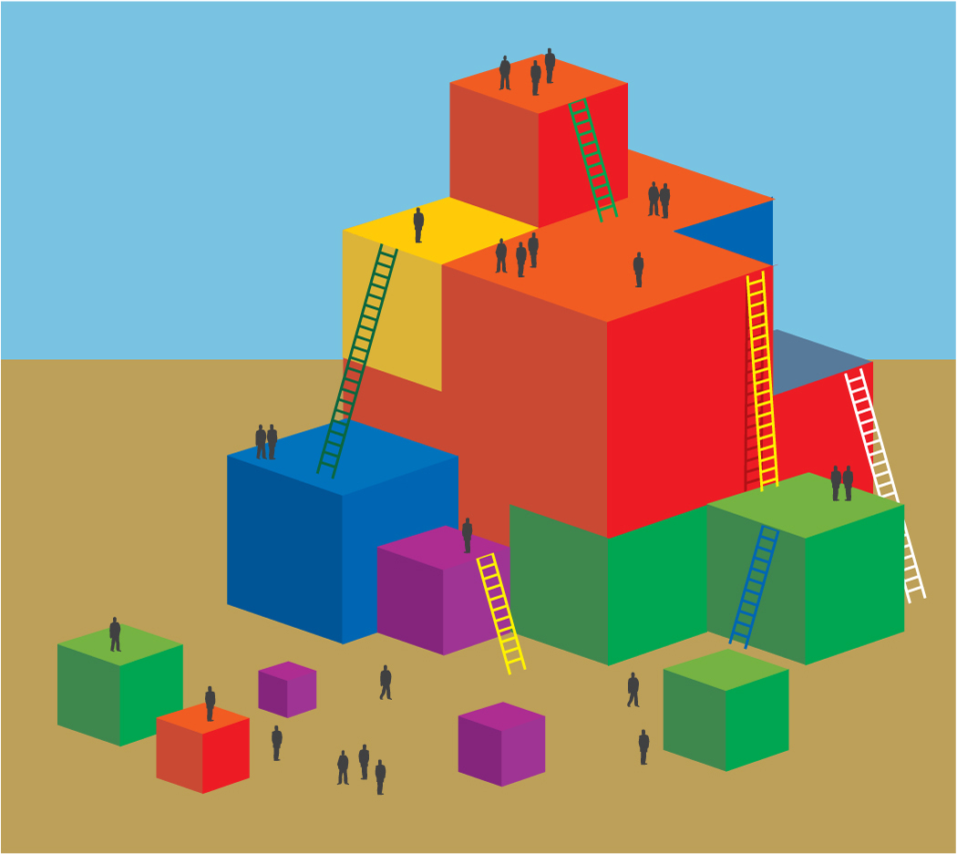**Process:**

1. Invite participants to find the Developmental Sequence Envelope.
2. Allow time for participants to put the Developmental Sequence Cards in order in table groups.
3. When all tables have completed the task, request participants turn to page 242 of the PCF to check their work.
4. Highlight how this knowledge may help teachers in gathering better evidence for the DRDP-K measures.
5. Share any interesting findings or discussion points from the group.
6. Debrief:

* Discuss how children may represent these developmental sequence levels differently.
* Think back to the Number Rock activity. How might your experience with this activity impact how you consider the developmental sequence?

MCj02958800000[1]

**SUMMARY**:

Participants practice identifying the counting developmental sequence.