Activity 5: Subitizing: Let’s Play





**intent:**

Participants practice subitizing knowledge through game play and analyze games with regard to the Preschool Curriculum Framework (PCF), dual-language strategies, the DRDP-K, Universal Design for Learning, and the Preschool Alignment Document.

**OUTCOME:**

Participants practice multiple games to be used in a preschool classroom.

MCBS00539A0000[1]

**Materials Required:**

* Handout 7: Learning Trajectory: Subitizing
* Handout 8: Subitizing: Let’s Play Worksheet
* Dancing ClockHandout 9: Teacher Support Strategies
* Index cards with 1–5 dots, as described in the Peace Card Game (2 sets per table group)
* 10 counters (e.g., acorns, plastic bears, plastic circles) per table group
* PowerPoint notes

**Time:** 20 minutes

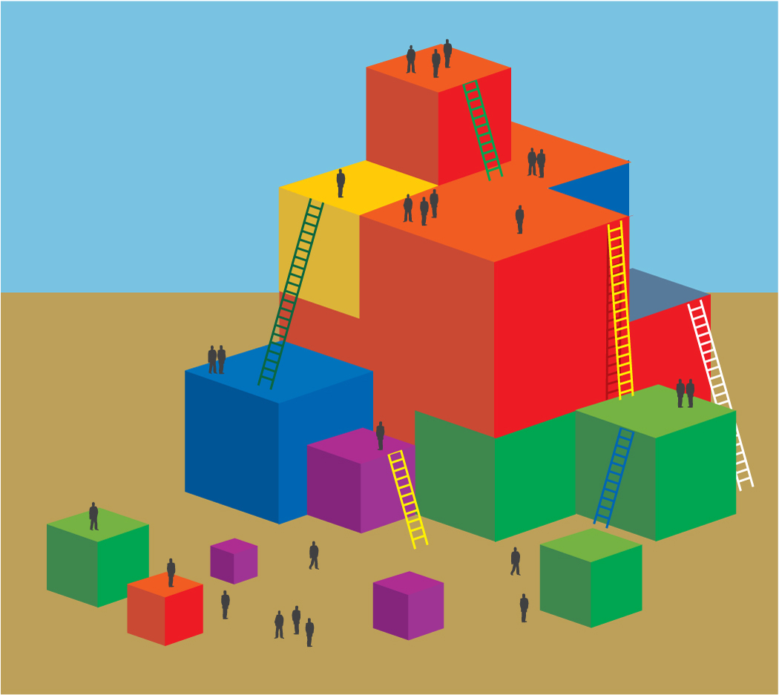**Process:**

1. Invite participants to read the last two pages of Handout 8 (subitizing games) and decide, with their table groups, which game to play.
2. Walk around and provide support for participants to practice each game. Allow 10 to 12 minutes for this exploration.
3. Regroup participants and demonstrate how to apply the game knowledge to the chart on the first page of Handout 8.
4. Walk around while participants think about and complete the first page of Handout 8 with their groups.
5. Invite participants to share out their “aha” moments. Presenters can also share out “aha” moments that they heard while walking around.