Activity 6: Number Rock



**intent:**

Participants take a “brain break” for an activity that introduces Universal Design for Learning.

**OUTCOME:**

Participants will experience multiple means of engagement and representation while dancing and/or singing to Steve and Greg’s “The Number Rock.”

Dancing Clock**Materials Required:**

* MCBS00539A0000[1]Access to Steve and Greg’s “The Number Rock” (via YouTube or computer download)
* Number Rock Envelope with direction cards and necessary materials (scarves)
* PPT notes

**Time:** 5 minutes

**Process:**

1. 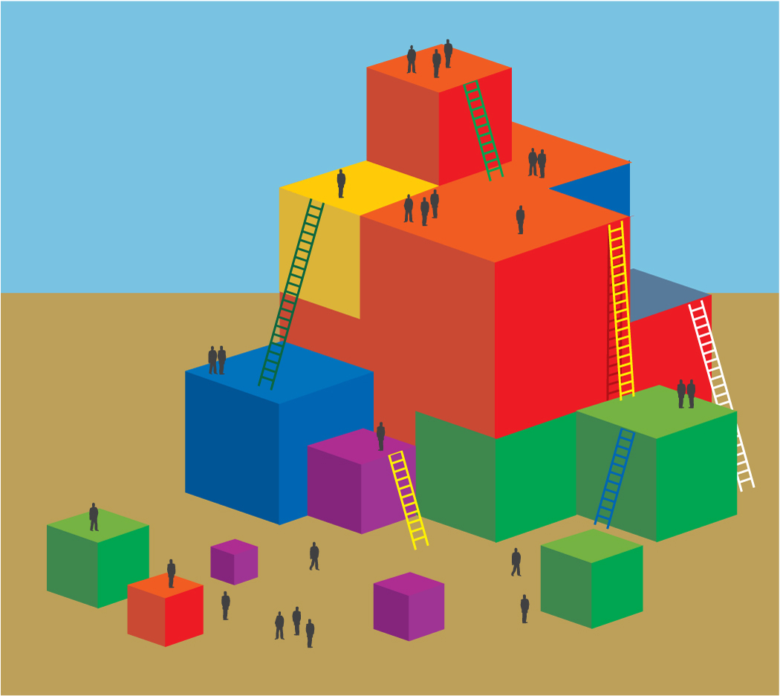Invite table groups to open the Number Rock Envelope on their table and read the direction card within.
2. When participants are ready, let them know that we will be doing the Number Rock, but that we will all be engaging in different ways.
3. Play the song and watch all participants as they engage with the song in different ways (some will be standing and dancing, some will be tapping along to the song with fingers, etc.).
4. After the song, debrief with possible questions:
   * How did this activity represent Universal Design for Learning?
   * In how many different ways did we engage in this activity?
   * In how many different ways did we represent numbers?
   * If you did this activity without the direction cards, what forms of engagement and representation might you see in your classroom?

MCj02958800000[1]

**SUMMARY**:

Participants engage in an activity to illuminate Universal Design for Learning.