Activity 7: Counting: Let’s Play





**intent:**

Practice counting knowledge through game play and analyze games with regard to the California Preschool Curriculum Framework (PCF), dual-language strategies, and the DRDP-K.

**OUTCOME:**

Participants practice multiple games to be used in a preschool classroom.

Dancing Clock

**Materials Required:**

* MCBS00539A0000[1]Counting Game Packet (Support Materials)
* Materials for the Pizza Game (1 per table group)
* Materials for Bears in a Cave (1 per table group)
* Handout 11: Counting Games
* Handout 12: DRDP-K Measures
* PowerPoint notes

**Time:** 20 minutes

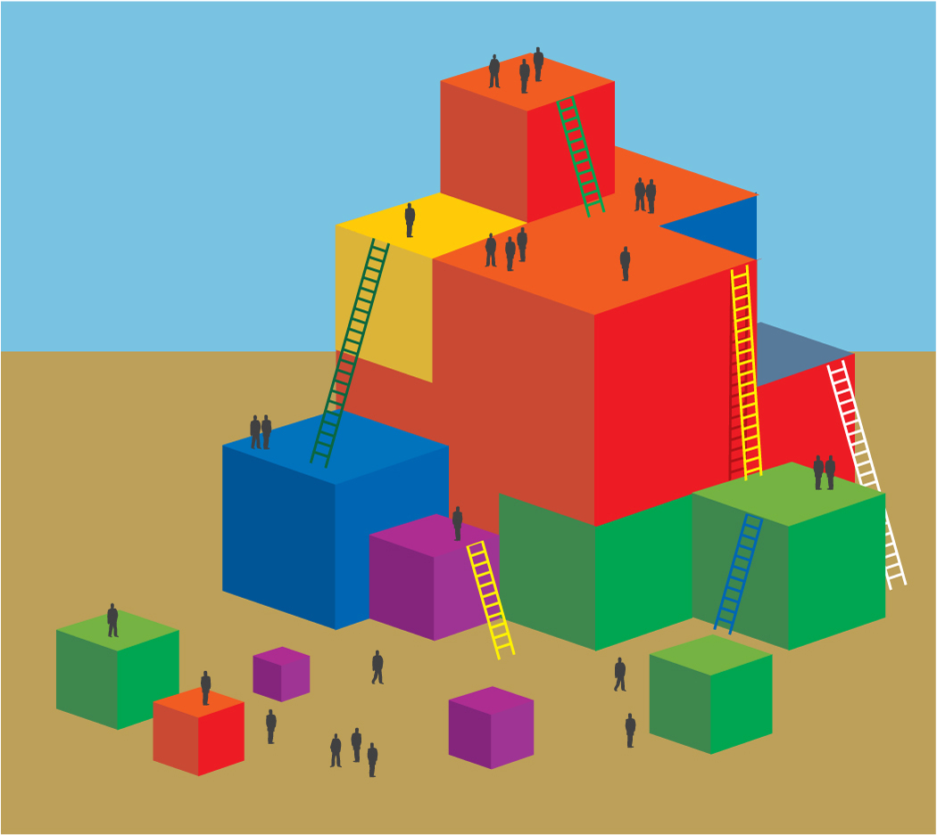**Process:**

1. Invite participants to read through Handout 11.
2. Invite participants to choose to play the Pizza Game or Bears in a Cave with their table groups.
3. After the table groups have played their chosen game, invite participants to read Handout 12, two math measures from the DRDP-K.
4. After participants have read the handout, invite table groups to discuss the questions on the slide:
   1. How might you scaffold the game, depending on individual students?
   2. How might you use these measures to support your teaching?
5. Allow five minutes for discussion. Walk around and listen to discussions, taking note of anything that you would like to share out or discuss with the whole group.
6. MCj02958800000[1]After the discussion, invite groups to share any conclusions or questions that they have about this experience.

**SUMMARY**:

Participants play and analyze counting games.