Activity 8: Engaging Families Blending Strategies!



**intent:**

Share ideas on how to partner with and engage families with math.

**OUTCOMES:**

Participants will become familiar with strategies for engaging families, gather ideas from one another, and create new strategies that will support them in engaging families.

Dancing Clock**Materials Required:**

* MCBS00539A0000[1]Chart paper
* Colored markers
* Handout 14: All About Young Children
* Handout 15: Engaging Families
* Handout 16: Blender

**Time:** 15 minutes

**Process:**

1. 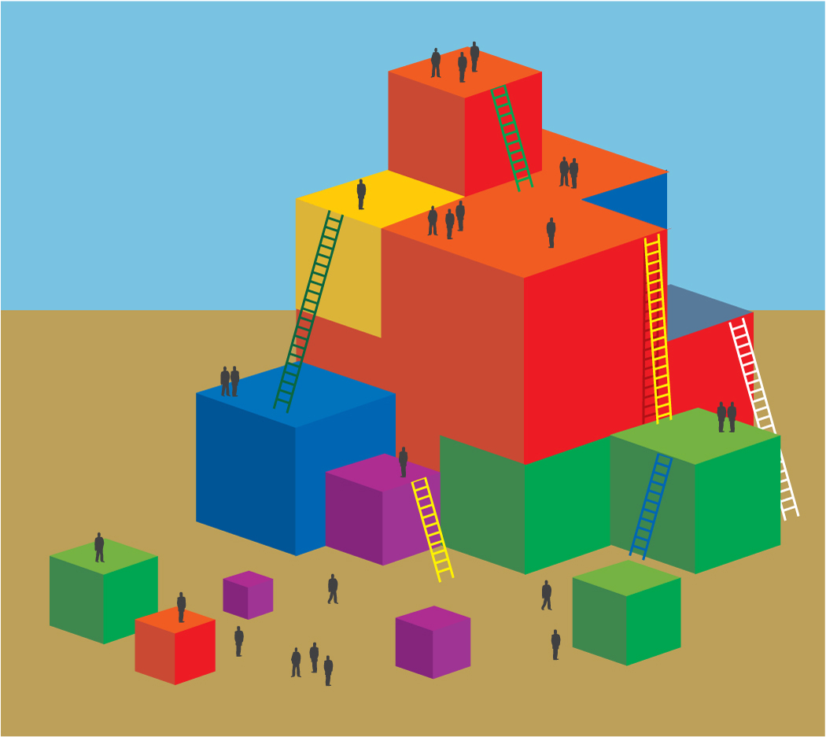Invite participants to read Handouts 14 and 15.
2. Have participants, in table groups, identify at least two different strategies that they would like to use for engaging families with mathematics and write them on the chart paper.
3. Invite participants to think about all of the experiences and discussions that they have had today, and, as a group, decide on 2–4 key things that they want to remember or try from today.
4. Invite participants to look at their chart paper with the ideas that they just wrote down for engaging families. Can they blend these ideas together and include families in the ideas that they want to try from the day?
5. Ask participants to discuss how they might blend these strategies together and to write down their ideas on the chart paper. They may also choose to take personal notes on Handout 16.
6. Invite participants to walk around the room gathering ideas from other groups.
7. Ask participants to discuss handout strategies with tablemates and come up with some of their own ideas, and to document them on their copies of Handout 16.