Activity 1: Name Your Shape





**intent:**

Stimulate the thought processes of the participants regarding the subject of geometry.

**OUTCOMES:**

Dancing ClockParticipants interact as they describe shapes while playing a shape game.

MCBS00539A0000[1]

**Materials Required:**

* Shape headbands (from construction paper)
* Paper shape cards
* PowerPoint

**Time:** 5 minutes

**Process:**

1. 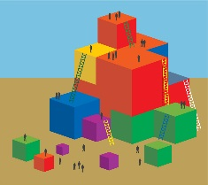Begin by quizzing the entire group about the shapes on the slide. For each shape, ask everyone to identify the shape, and then reveal the shape name.
2. Once all shapes are revealed, request that everyone participate in the “Name Your Shape” game.
3. Explain that the rules are similar to a card game they may have played in the past. Each participant will need a paper headband; have them choose one now.
4. Have each participant take a shape card from the middle of the deck, without looking at it, and place it on their headband.
5. Participants ask tablemates yes-or-no questions to try to determine which geometric shape is on their headband.
6. Debrief:
   * Aside from having fun, what did you find interesting about this game?
   * Was it surprising how much language you used to describe your shape in detail?
   * What other forms of information did you use to guess your shape? (Connect this to the Universal Design for Learning (UDL) principle, *Multiple Means of Expression and Representation*.)

MCj02958800000[1]**OPTIONS:**

* Play the game silently with participants acting out the shapes to each other.
* Play the game in pairs. Put a time limit on the clock and have only one partner talk at a time, switching when the time is up.