Activity 2: Foundations Map Explained in Numbers





**intent:**

Explore the math foundations with participants.

**OUTCOMES:**

* Participants examine foundation map and explore terminology used in the California Preschool Learning Foundations (PLF).
* Participants compare the age-level progression within the PLF.

Dancing Clock

**Materials Required:**

* MCBS00539A0000[1]Chart paper
* Handout 2: Foundation Map
* Handout 3: Foundation Note Chart
* PowerPoint notes
* PLF

**Time:** 15 minutes

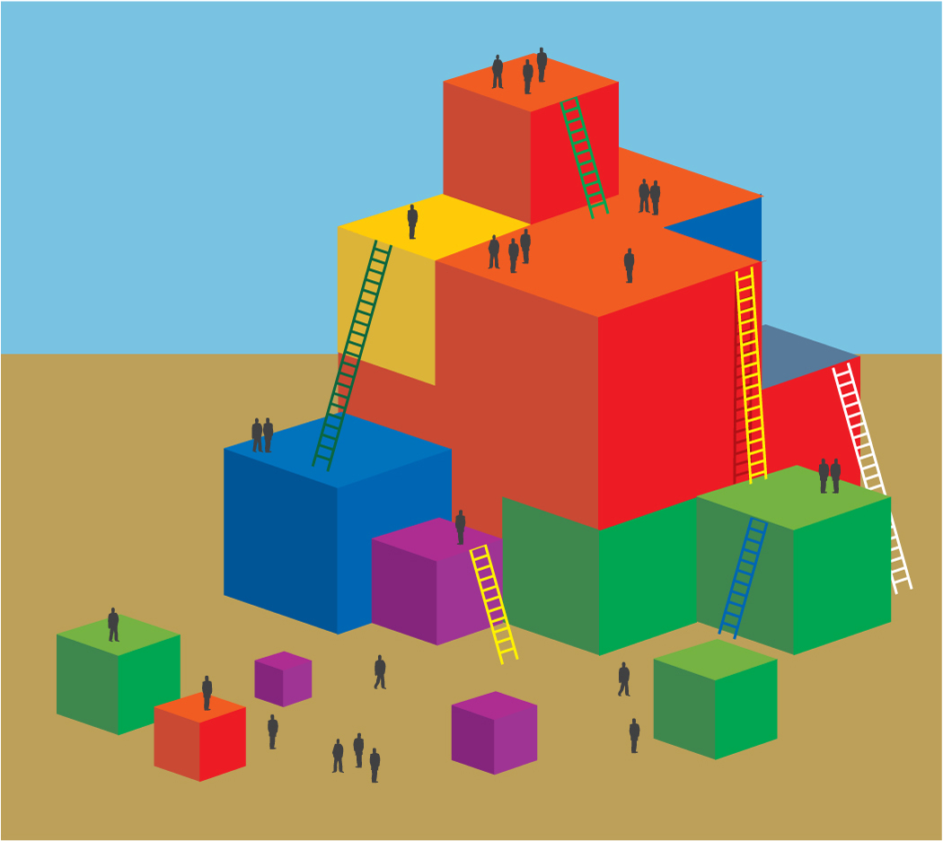**Process:**

1. Prior to the training, create one chart paper per table group, with the outline of Foundation 1.2 of Number Sense. An example is included on the reverse side of this activity plan.
2. Show participants the components of the map numbered 17.
3. Invite participants to work together to complete the foundation map on the chart paper with all seven components and then use the numbered labels to label the map.
4. As the groups work together, walk around the room to listen to conversations. Take note of anything that might benefit the whole group.
5. After all groups have completed, ask for any reflections and share what you wrote down while walking around (if beneficial).
6. Ask participants to look closely at Handout 2 and compare the growth between 48 and 60 months.
7. Have participants refer to Handout 3 and write down anything that they notice as important, especially within the progression between 48 and 60 months.
8. Share with participants that Handout 3 can be used to take notes and save ideas about the foundations throughout the training.
9. Provide three to five minutes of time for participants to navigate the map and the foundations, and to take notes.
10. Ask participants to share what they have noticed.

Trainer Preparation Directions: Hand-write this on one chart per table group.

_____________________________________________________________ (1)

________________________________________ (2)

(3)

|  |  |
| --- | --- |
|  | (4) |
|  | (5) |
|  | (6) |

(7) *