Play It—Chart It—Share It



intent:
Practice geometry games, apply learning trajectories, and share other related ideas with the group.

OUTCOMES:
Participants apply knowledge learned throughout the day.

Materials Required:

- PowerPoint slide
- Handout 3: Math Toolbox Trajectories
- Handout 4: Game Packet
- Chart paper

Time: 20 minutes
Process:
Prior to Training:
- Prepare 6-8 pieces of chart paper with the following questions:
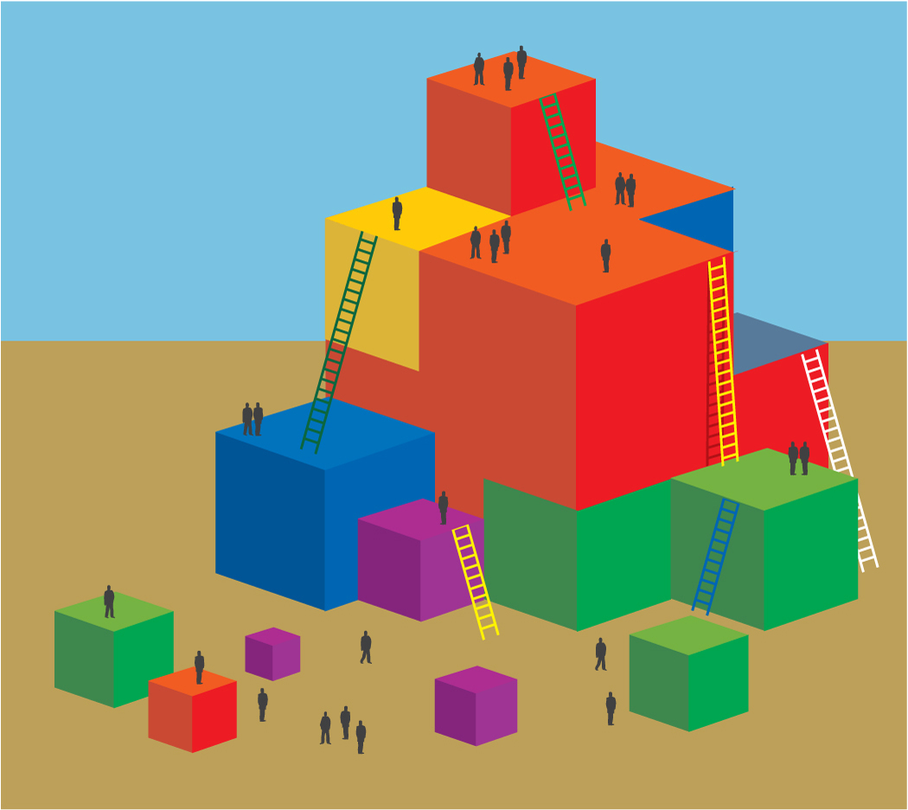
- What was fun about the game?
- What foundations were addressed in the game?
- What components of the learning trajectory are emphasized in the game?
- What might be important to consider for students learning more than one language?
- What other domains/content areas are addressed in the game?
- Use butcher paper, construction paper, or poster board to cut out 8-10 large shapes and tape them to the floor around the training room.
- Trainer explains the following:
- In this activity, we are going to have an opportunity to play games and then consider how the game is facilitating different types of learning using Handout 3: Math Toolbox Trajectories. Then we will use this information to consider how to scaffold children with the California Preschool Learning Foundations and the DRDP-K (2015).
- First we will model how to do this as a whole group, and then we will break up into smaller groups and do it again.
- The first game we are going to play is the Shape Step Game. It is the first game in Handout 4: Game Packet.
- Around the room you notice shapes on the ground. When the music plays, wander around the room. When the music stops, listen to directions and go stand on a shape.
- Everyone is invited to play this game, but please regulate your own body.
- Presenter note: Once everyone is standing on a shape, follow the directions of the Shape Step Game. Play the game for about 2–3 minutes. Then ask everyone to come back to their seats and lead them in a group discussion. You may choose to have a co-trainer or volunteer participant chart your discussion:
- What was fun about the game?
- What foundations were addressed in the game?
- What components of the learning trajectory are emphasized in the game?
- What might be important to consider for students learning more than one language?
- What other domains/content areas are addressed in the game?

- Trainer explains that participants may choose another game and do the same process with their table group. Participants should chart responses using the chart paper at the table and be ready to share when it is complete.

Optional Ways to Debrief:
- Invite participants to hang charts around the room so everyone can read the charts.
- Invite each group to share out the three key take-aways from this experience.
- Invite table groups to pair up and exchange thoughts with another groups who chose a different game.

