Creating Invitations Through the Environment



intent:
Explore the section on measurement in the framework with regard to suggestions for the learning environment.

OUTCOME:

Participants will create a list of materials to add to their environment that support learning in regards to measurement.


Materials Required:
- PCF (pp. 272-280 – Measurement),
- Handout 5: Creating Invitations through the Environment (comparing, ordering, and measuring)

Time: 20-30 minutes

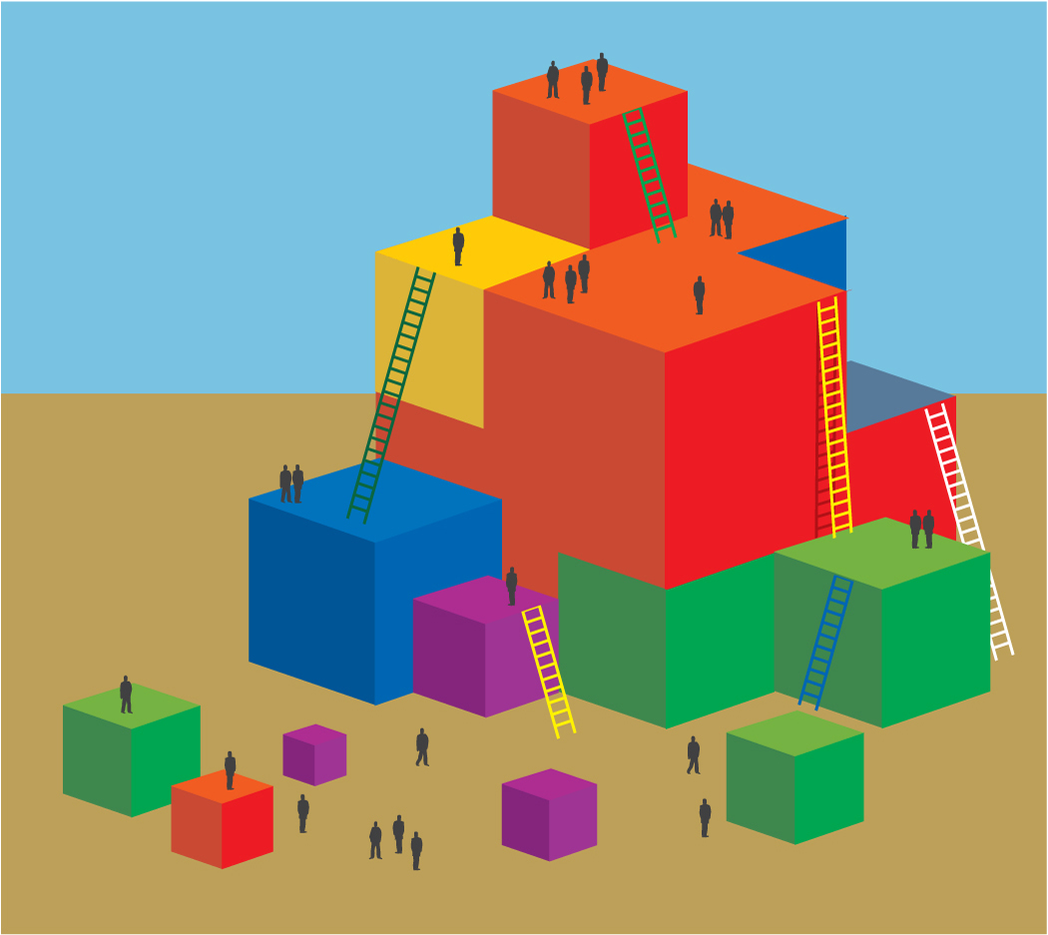
Process:
- Participants read through the measurement sections listed above and record the ideas they find within the text and through table discussion.
- Give participants 25 minutes to work on handout.
- Participants should also be encouraged to record their own ideas. Ask groups to share their findings with a neighbor table.

OPTIONS:
Post chart papers labeled with the different interest areas and assign one interest area to each table. (See the handout for a list of the interest areas.) Participants will move from chart to chart, adding ideas until they end up back at the first chart. This allows them to see what other groups have added.

If time allows, give participants 10 minutes to record their favorite ideas from the charts onto the worksheet. Instead of using the interest areas, have participants think about parts of the daily routine and do the same steps listed previously. Jigsaw the pages of the framework section so participants have fewer pages to read.

