Geometry Hunt for Five Fabulous Ideas





**intent:**

Gather ideas for adding geometry to the environment.

**OUTCOMES:**

Participants will read the *Mathematics Framework for California Public Schools: Kindergarten Through Grade Twelve* (Math Framework), and the *California Preschool Curriculum Framework* (PCF) to find ideas for adding geometry to the environment.

Dancing Clock**Materials Required:**

* MCBS00539A0000[1]Handout 9: Math Framework TK Chapter‒Geometry
* Handout 10: PCF Environments and Materials
* Chart paper
* Chart markers

**Time:** 15 minutes

**Process:**

1. Guide participants to find Handouts 9 and 10.
2. Invite table groups to:

* 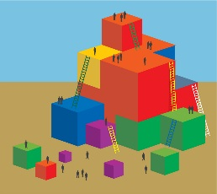Read and highlight ideas from handouts for adding geometry to the environment.
* Brainstorm a list of all of the ideas from today’s training and the reading for adding geometry to the environment.
* Come to agreement on the top five fabulous ideas to share. Put these ideas on chart paper and hang it on the wall.

1. Once all groups have hung their chart paper, invite participants to view the fabulous ideas. Suggest they can take photographs of the charts.