Activity 6: Geometry Suitcase




intent:
Apply geometric information from multiple California Department of Education resources to everyday interactions with children.

OUTCOMES:

Participants identify one key piece of information from a CDE resource.

Materials Required:

- Handout 11: Geometry Suitcase
- PLF Volume 1
- PCF Volume 1

Time: 20 minutes

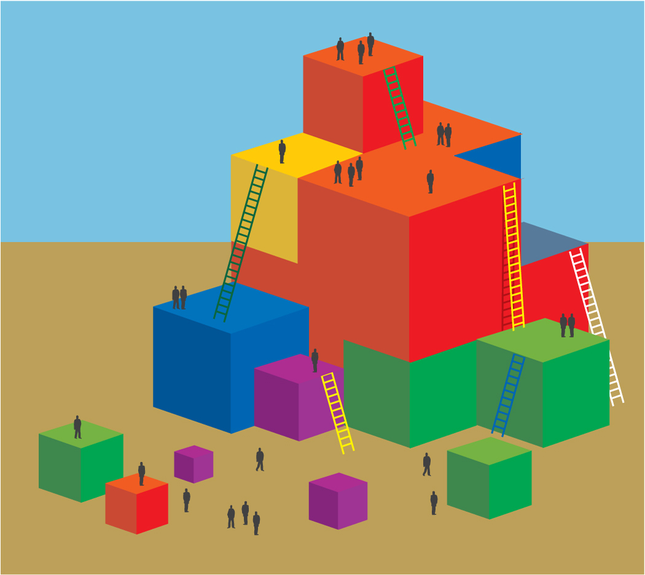
Process:
- Guide participants to find Handout 11.
- Guide Participants to read the light gray boxes on the handout with an elbow partner.
- After reading ask participants to work with their partner to come up with at least two other key strategies that might be used to support geometric development in the classroom.
- Finally invite participants to circle one strategy they will implement in their classroom next week.

SUMMARY:
Participants read the handout, share thoughts, and reflect on how to expand on their ideas in their classrooms.

