Minute to Win It: Measurement



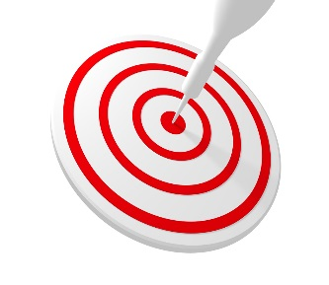

**intent:**

Practice non-standard measurement and participate in active movement.

**OUTCOME:**

Participants will create a list of ways to measure a table tent with non-standard measurement and have a brain break.

Dancing Clock

MCBS00539A0000[1]**Materials Required:**

* Table tent
* Objects on the table to use for non-standard measurement (comparing, ordering, and measuring)

**Time:** 20-30 minutes

**Process:**

1. 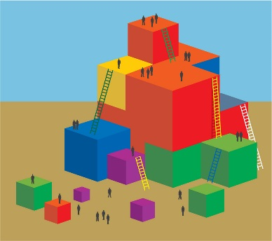Participants find the table tents on their tables.
2. Trainer demonstrates how to measure the table tent with non-standard measurement using a thumb (about 13 thumbs long).
3. Inform participants they will be playing Minute to Win It:
4. Measurement. All table groups will have one minute to measure the table tent in as many ways as possible, utilizing any form of measurement they can find. At the end of one minute groups will be asked for the list of they used.
5. Remind participants to record measurements as a group for reference.
6. When all participants are ready start the timer.
7. At the end of one minute, finish the activity by having table groups share out how they measured. Clap for the group with the most forms of measurement, and clap for the group with the most creative forms of measurement.