Measurement Walk – Part 1:



Non-Standard Measurement

**intent:**

Explore information in the *California Preschool Learning Foundations* (PLF), *Volume 1* and the *California Preschool Curriculum Framework* (PCF), *Volume 1.*

**OUTCOME:**

Participants differentiate instructional support approaches when introducing opportunities to measure objects.

**Materials Required:**

* MCBS00539A0000[1]PLF (Mathematics domain, Measurement strand, foundations 1.1 and 1.3)
* Dancing ClockPLF (pp. 163-164 – Measurement)
* PCF (p. 273 – “Compare, Order, and Measure Objects”)
* Measurement Journal
* 4-5 different measuring tools
* Pencil or marker

**Time:** 10 minutes

**Process:**

1. 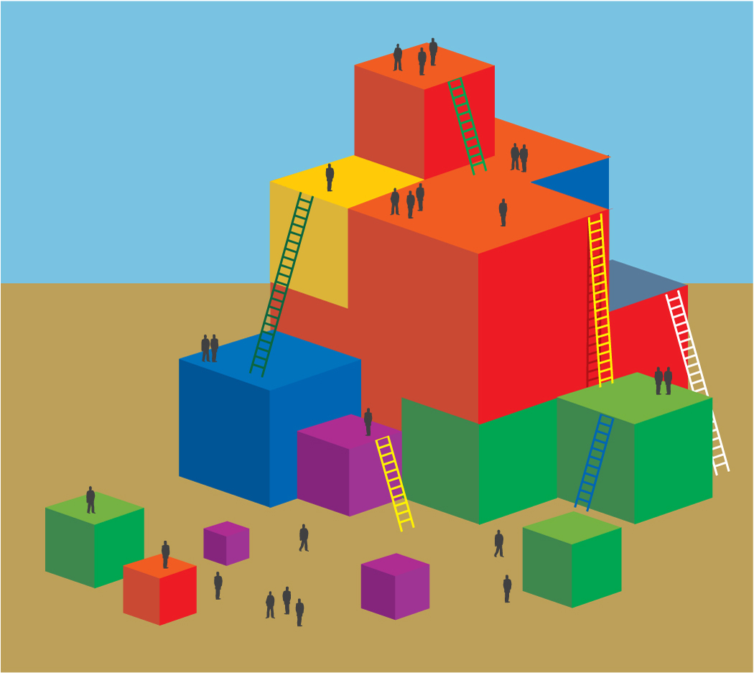Individual activity: Participants read through the measurement sections listed above.
2. Large group discussion: What is the difference between mathematics foundations 1.1 and 1.3?
   * How can we support children at each level?
3. Participants will break into smaller groups to go on a measuring walk outside.
   * Group sizes will depend on the number of participants.
4. Each group will assign a recorder to take notes (using the journal) on how the group measured various items in the environment.
5. Each group is to measure 4-5 objects using 4-5 different measuring tools.
6. Report out as time permits.

Measurement Walk – Part 2:



Standard Measurement



**intent:**

Explore the information in the *California Preschool Learning Foundations* (PLF), *Volume 1* and the *California Preschool Curriculum Framework* (PCF), *Volume 1.*

**OUTCOME:**

Participants will differentiate instructional support approaches when introducing opportunities to measure objects.

**Materials Required:**

* MCBS00539A0000[1]PLF (Mathematics domain, Measurement strand foundations 1.1 and 1.3)
* Dancing ClockPLF (pp. 163-164 – Measurement)
* PCF (p. 273 – “Compare, Order, and Measure Objects”)
* Measurement Journal
* Book - *Inch by Inch* by Leo Lionni
* Pencil or marker

**Time:** 15 – 25 minutes

**Process:**

1. Participants read through the measurement sections listed above.
2. Large group discussion:
   * What is the difference between mathematics foundations 1.1 and 1.3?
   * How can we support children at each level?
3. Give each participant an inchworm ruler.
4. In table groups, participants measure 4-5 objects using the Inch Worm Ruler (a standard unit of measurement).
5. Participants record findings in their journals and report out as time permits.

**OPTIONS:**

* 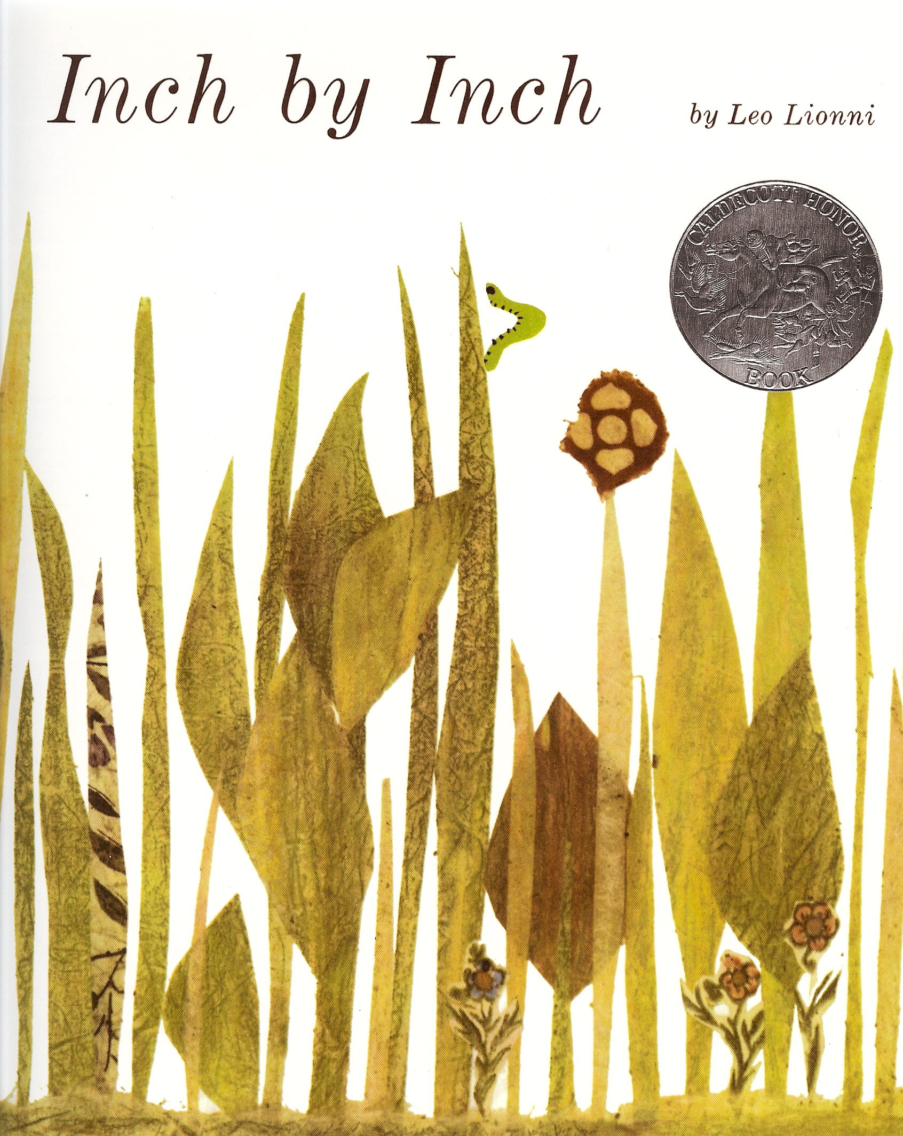Jigsaw the reading assignment and have participants share out their section with table group.
* Have participants go outside or out of the room to find things to measure.