Button Attribute List

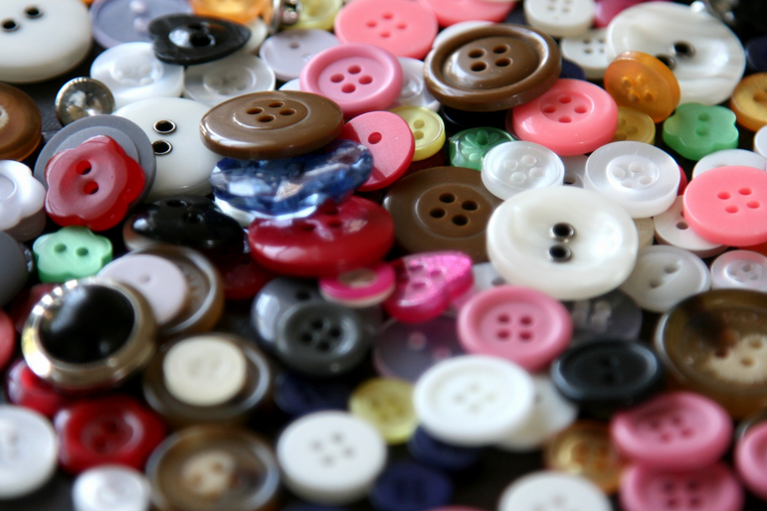

1. Size
2. Color
3. Shape
4. Holes
5. Thickness
6. Weight
7. Material
8. Texture
9. Design
10. Pattern