Weaving Alphabetics
Into Your Day
(in a fun and playful way!)

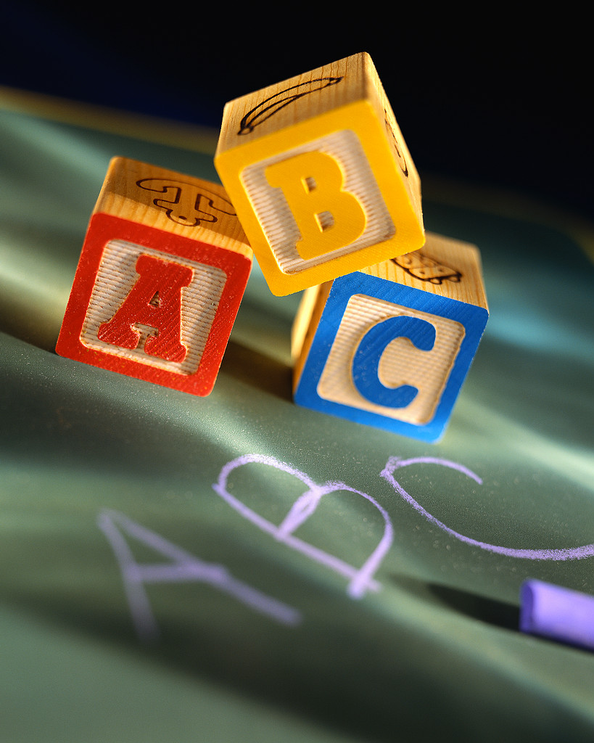

“It is important for your child to know the alphabet as accurately as possible before she enters school. She needs to instantly and effortlessly recognize all the letters so that she is prepared to dedicate all her attention to other tasks (in kindergarten), such as learning the sound association with each letter and how to write it correctly.” (Moats, 1999)

Knowing the alphabet means having an anchor for each sound

Recommended order for teaching alphabet skills

Names-recite the ABCs, the letter name is constant

Shapes-This is a B. Letter shapes come in upper and lower case

Sounds-This is a B and it says ‘buh,” letters can make different sounds depending on which letters surround them


Cindi Kaup, Region 1

Naming Activities
building awareness (2-4 years old)

- ABC song and variations on this theme
- Hap Palmer CD- Can a Jumbo Jet Sing the Alphabet?

- Read ABC books Have the child share the letter
- ABC puzzles –matching letters
- Whole body letters
- Provide a print rich environment-opportunities to bring
attention to and discuss meaningful print (“Look at that,
lunch and lasagna both start with the letter L”)

- Display a printed alphabet at the child’s level
- Alphabet tracking
- Alphabet cheers!
- Provide alphabet placemats in writing areas, ABC
cookie cutters with playdough, ABC shapes for
sand/water play

- Food/baking activities-crackers, pasta, pretzel/biscuit letters

- “My name” activities
Use child’s picture with their name
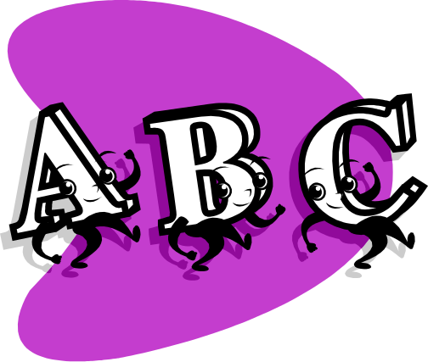
Carpet squares
Attendance
Name puzzle
Letter detectives

- Sensory letters/names

Printed Letter Recognition Activities
focusing on the shape (4-5 years old)

- Start with upper case (52 letters can be very confusing!)
- Forming letters with clay, in sand, shaving cream
- Alphabet letter tiles
- Letter activity cards
Sensory letters, sorting different fonts, matching upper and lower case
Consider making each line segment a different color, so children see where each segment ends
- Alphabet clue game
Occasionally draw attention to letters while taking dictation from children
- Three dimensional letters-magnetic, large wooden, sponge
- Rainbow Activity

- Skywriting, back writing
- Letters in a bag activity
- Letter hunt

Sound Activities
Drawing attention to the sound association (5-6 years old)

- Rather than teaching isolated lessons on letter-sound relationships, it is more effective to point out these relationships in the context of meaningful learning opportunities (dictation, name games, songs)
- Most letters sound like their name (notable exceptions are h, w, y)
- Letter scrapbook
Among pre-reading skills studied by researchers, that which consistently predicts later success in reading is accurate, rapid letter naming. (Snow, Burns and Griffin, 1998)

Print Rich Environment
Book area: Magazines, variety of books
House area: Cereal boxes and other food containers, calendar, recipes, menus, grocery bags with print, coupons, catalogs
Block area: Small road/construction signs, vehicles with print, photos of buildings with print, maps, wooden ABC blocks
Art area: Magazines, newspapers, catalogs, junk mail, cards, ABC stamps, sponges, cookie cutters
Toy area: Puzzles, board games, alphabet toys and puzzles
Music area: Tapes, records, song cards, songs written on charts
Computer area: Appropriate reading-related software

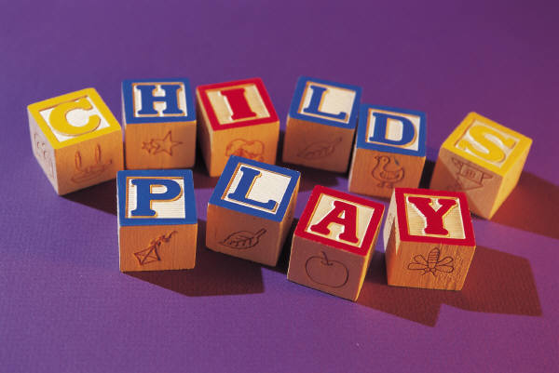

References
Campbell, K. (2003) Art Across the Alphabet
Hall and Moats, (1999) Straight Talk About Reading: How Parents Can Make a Difference During the Early Years
Ranweiler, L. (2004) Preschool Readers and Writers, Early Literacy for Teachers
Schiller and Moore, (2004) Do You Know the Muffin Man?
Snow,C.E.,Burns, M.S and Griffin, P. (1998) Preventing Reading Difficulties in Young Children
Strickland D.S. and Schickedanz J. (2004) Learning About Print in Preschool, Working With Letters, Words, and Beginning Links With Phonemic Awareness

