Use the Preschool Learning Foundations (PLF), Preschool Curriculum Framework (PCF), and articles to create a list of potential physical science experiences you might observe in each area. Then list an interaction and strategy (with page number) from the PCF that could be used to enhance each experience. The strategy may be from the physical sciences, scientific inquiry, or environments sections.
Area | Physical science experience you might observe: | Interaction and strategy from PCF that would expand experience: | Area | Physical science experience you might observe: | Interaction and strategy from PCF that would expand experience:
Art  Area   |  |  | Literacy  Area  
Block  Area  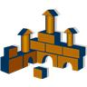 |  |  | Science or Discovery Area  
Small Toy Area  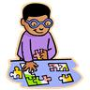 |  |  | Dramatic Play Area  
Outdoor Area   |  |  | Math Manipulative Area