HOW TO MAKE A HOMEADE STREAMER
By Patty Kimbrell, M.Ed.
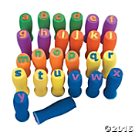
Supplies:
- Easy to Grip Lowercase ABC Stamps (item # IN-56/2330 at Oriental Trading Company)
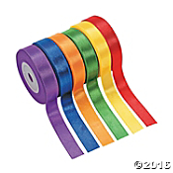
- Super Sensational Ribbon (item # IN-57/9084 at Oriental Trading Company)
- Scissors (if children are helping, supervision is a must!)
- Measuring tape
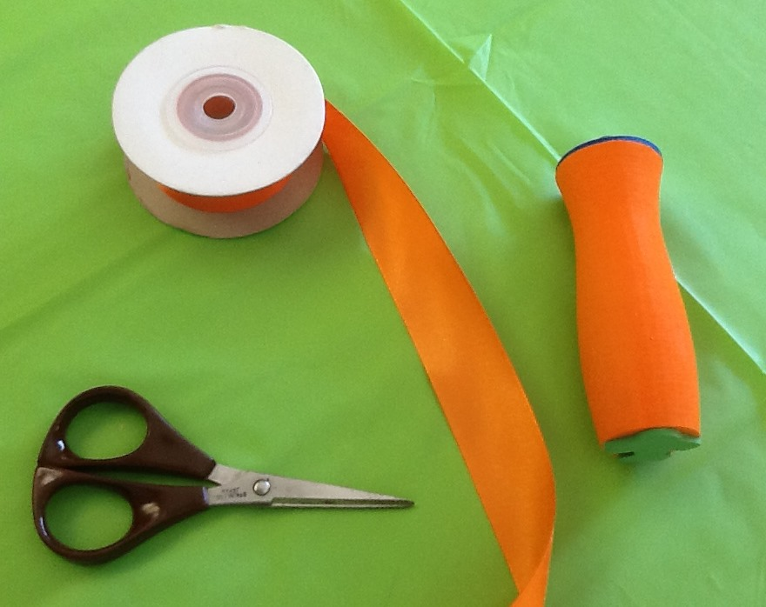
Directions:

- Gather items needed.
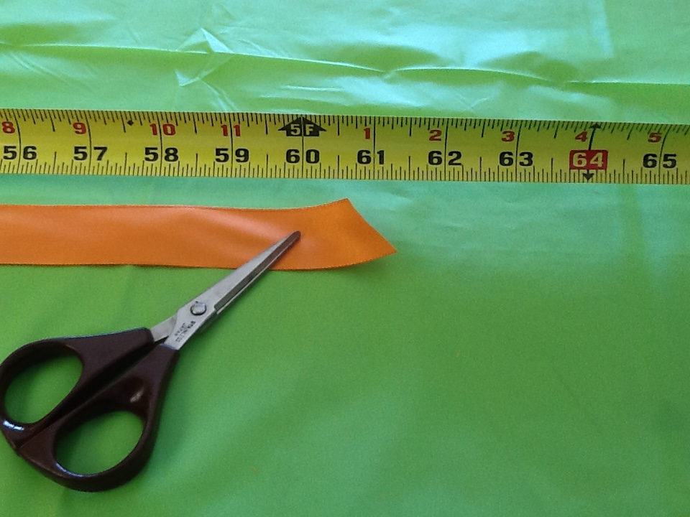

- Measure a five-foot length of ribbon and cut – matching the ribbon to the stamper is suggested. If available, to prevent fraying of ends, dip the ends of the ribbon into a solution called “Fray Block” (available at Wal-Mart or fabric stores).
- Center the ribbon and tie a double knot around the stamper. Make sure every child has a streamer to play with – explore the endless possibilities of streamer play. Don’t forget to integrate colors, shapes, letters and numbers too!
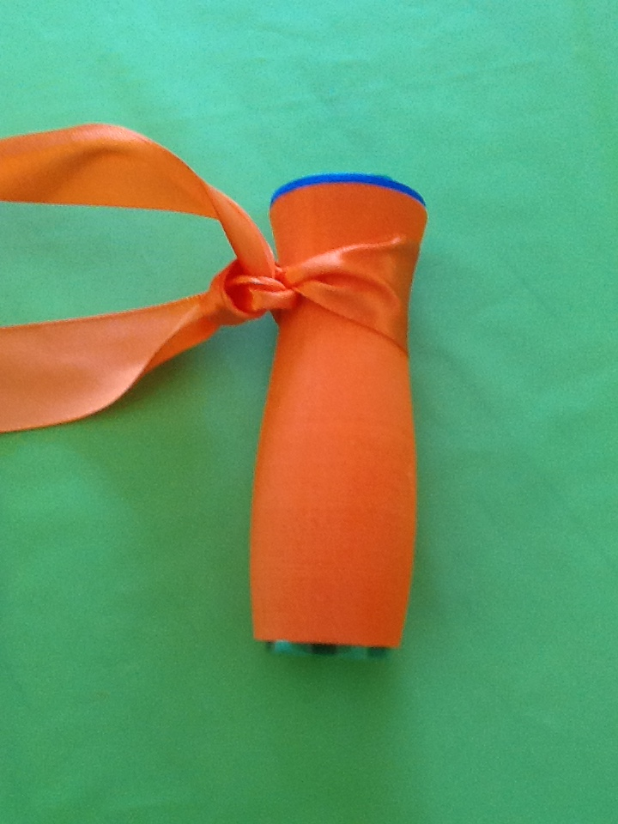
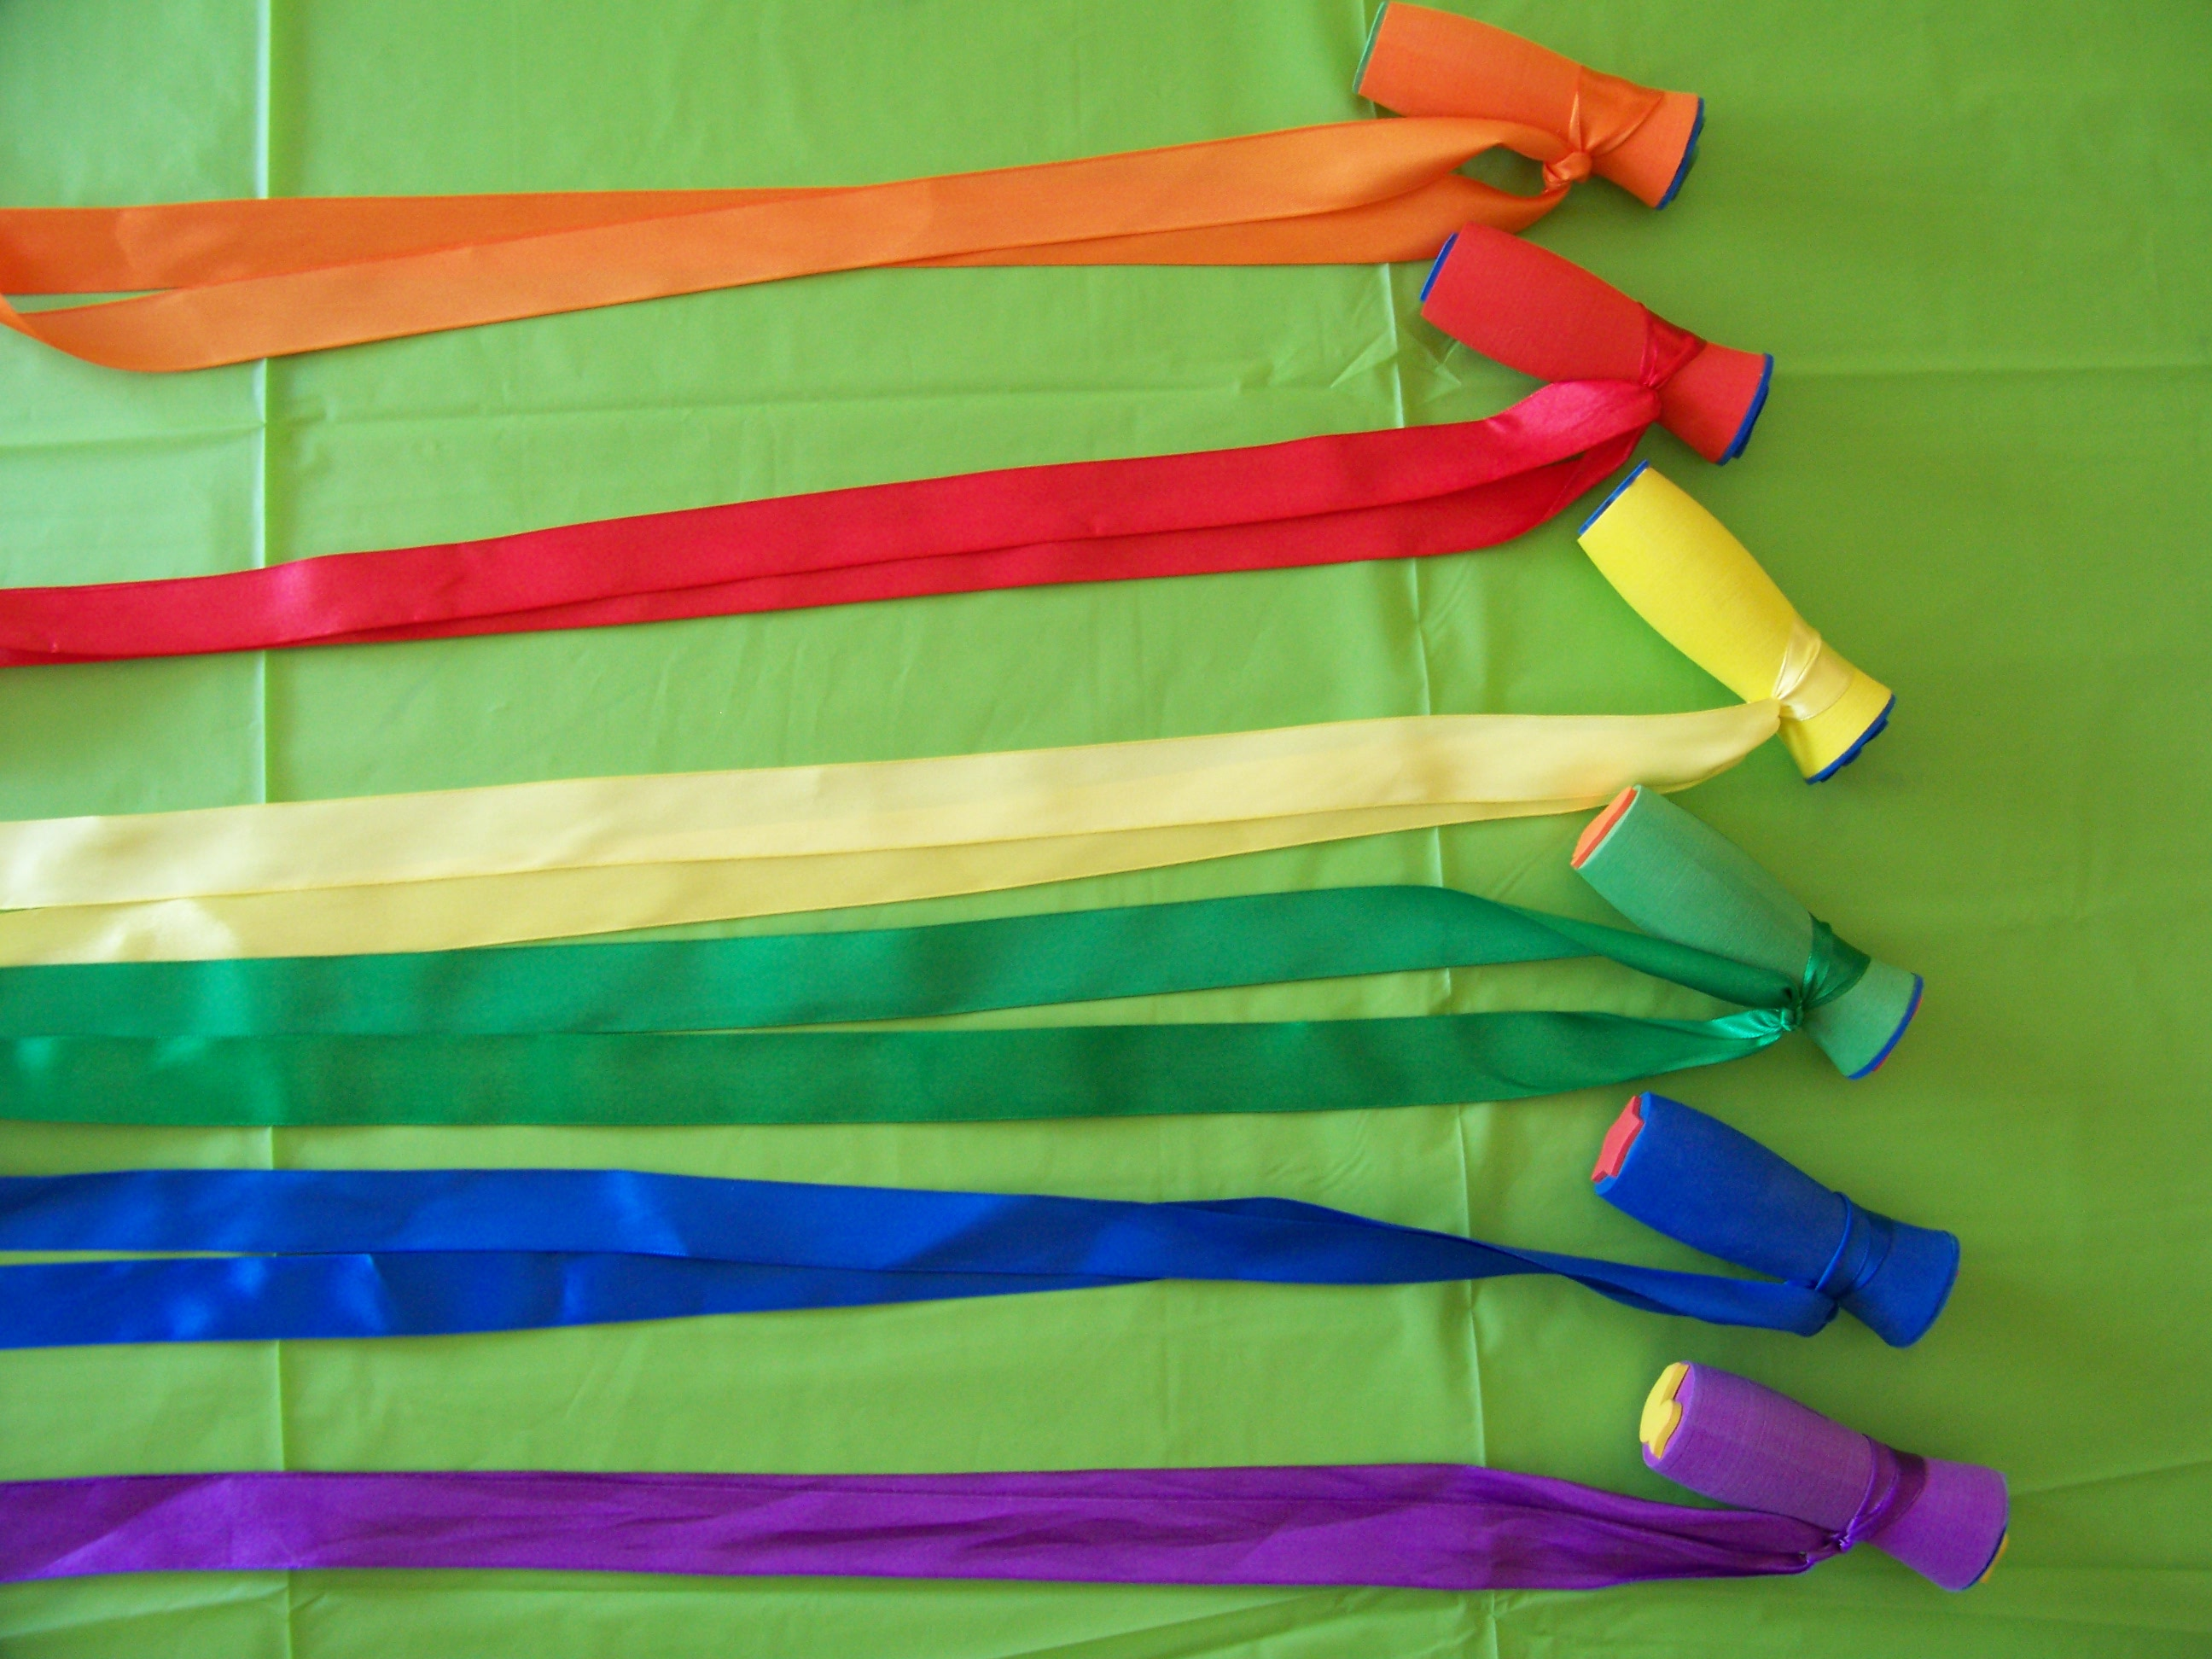

Make It Take It Supply Information
Oriental Trading Com
www.orientaltrading.com

Allow 2-3 weeks for ordering and delivery

Prep time: 30 minutes

Each participants needs one ribbon and one gripper stamp
Place items in a sandwich bag

Super Sensational Ribbons

IN-57/9084

$7.50 1 Set or $6.99 - Qty 3 or more

(6 pcs. per unit) 1/2" x 10 yds.

http://www.orientaltrading.com/super-sensational-ribbons-a2-57_9084.fltr?prodCatId=552705

Easy to Grip Lowercase ABC Stamps

IN-56/2330

$14.99

(26 pcs. per unit) 1" © OTC

http://www.orientaltrading.com/easy-to-grip-lowercase-abc-stamps-a2-56_2330.fltr

