Circle the tools you have in your program:
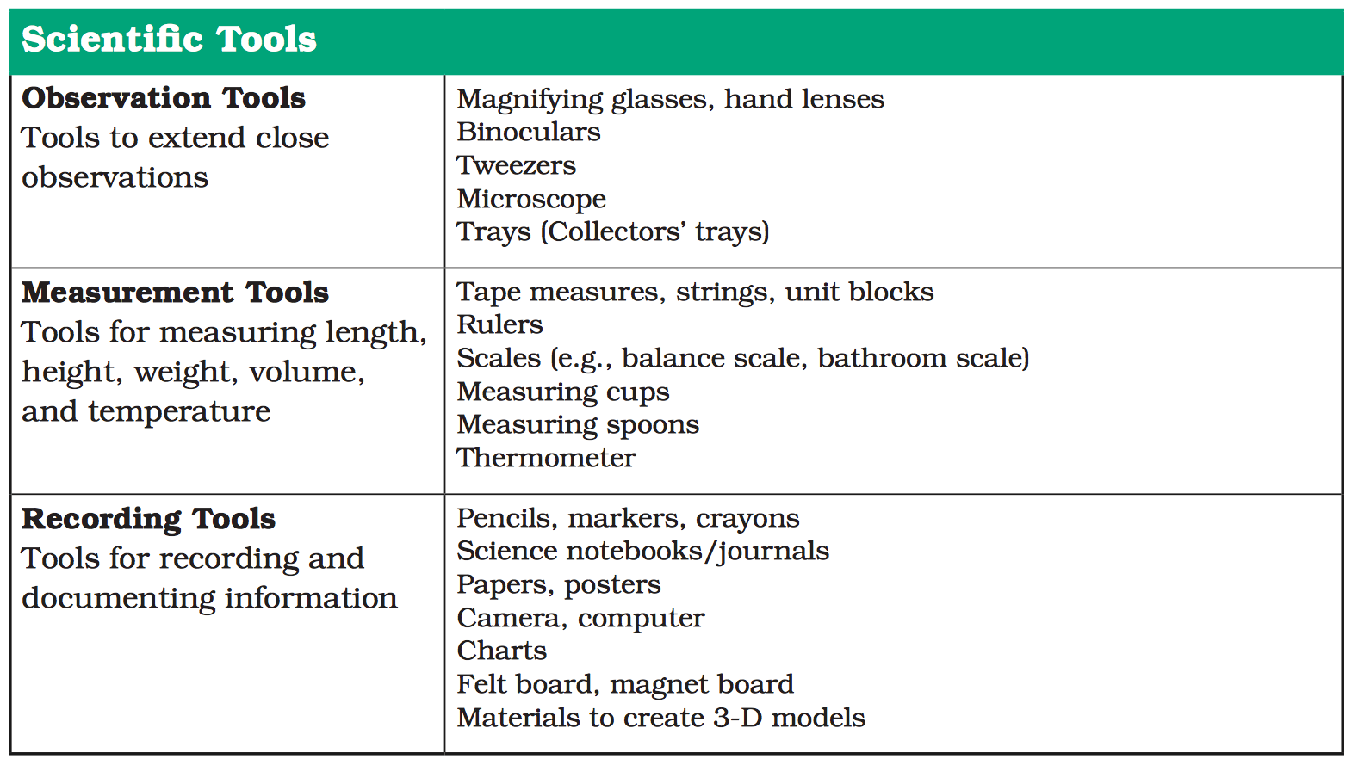

Swap Meet Chart: In the left hand column, describe two great ideas for using one or more of these tools in your program. Then find someone to swap ideas with. List the new ideas in the right hand column.

Swap Meet
Your ideas for using tools: | New ideas for using tools:

