### A fishing tackle box, lunch box, or briefcase filled with writing tools and paper can create an excellent “Writing Suitcase” for a child to take home and utilize to draw, color, or write.

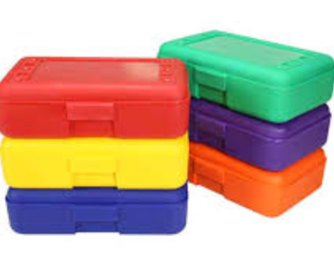

**Dear Family,**

**Today is my turn to bring home the “Writing Suitcase.” I’m so excited! I can hardly wait to create something—color, write, draw,**

**or whatever I want to create all by myself.**

**Please help me take care of this suitcase and help me remember**

**to return it to school tomorrow.**

**Thank you,**

**Your child**

**P.S. I can bring my project to school to share with my friends.**