**List of Books**

Note: These books may be purchased on Amazon.com, a local bookstore, or checked out at the local public library.

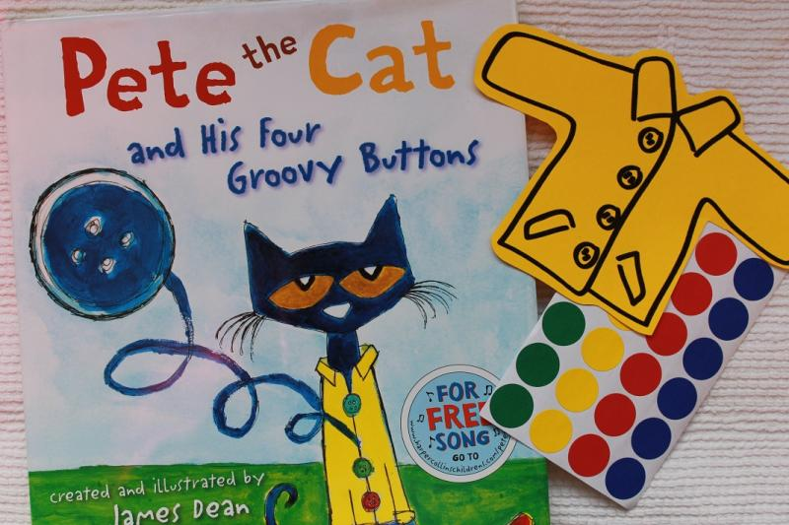 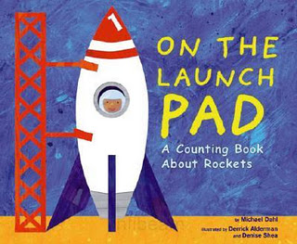 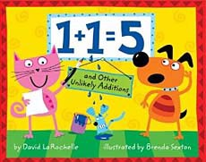

**Pete the Cat On the Launch Pad 1+1=5**

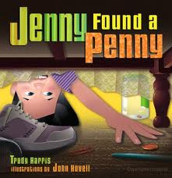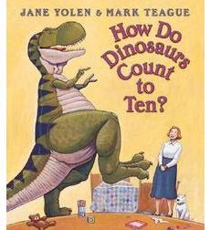

**How Do Dinosaurs Count to Ten? Jenny Found a Penny**

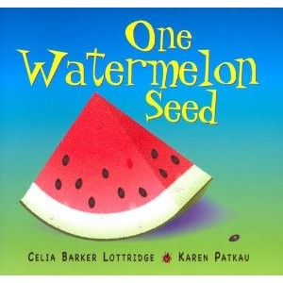 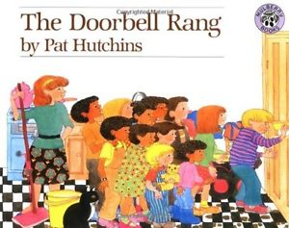 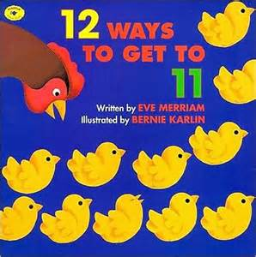

**One Watermelon Seed The Doorbell Rang 12 Ways to Get to 11**

Math Vocabulary

Same Different Color

Soft Hard Rough

Smooth Big Small

Short Long Tall

Wide Narrow Thick

Thin Size Under

Over In On

In back of In front of Next to

Inside Outside Through

High Low Near

Far Shape Curved

Sides Round Roll

Stack Ball shape Box shape

Pointed Cone Sort

Group Together Compare

Order Before After

Next Then Count

Pattern Design Match

Repeat Corner Sides

Numbers Many Few

More Less Empty

Full Heavy Heavier

Light Lighter Flat

Square Circle Triangle

Round Subitize Estimate

**My Favorite Books and Your Favorite Books**

**Directions**: List favorite books to use in the classroom that integrate number sense knowledge. Once the music plays, walk around the room and ask other participants to share their favorite books. (List these books under Your Favorite Books.) Once the music stops, return to your seat.

|  |  |
| --- | --- |
| **My Favorite Books** | **Your Favorite Books** |
|  |  |