Shape Step Game

This game focuses on the parts and properties of shapes.

Materials needed: Various manipulative shapes on the ground, or shapes created with tape on the ground.

Who: Small groups or large group (if you have enough shapes)

How to:
- Teacher asks children to step on a triangle, step on a square, etc.
- Name the shape.
- Describe the shape.
- Repeat using the various shapes.

Teacher reflection: What are children learning as they participate in this activity?

Activity adapted from: Clements & Sarama 2007.

Match and Name Shapes

Materials needed:
- Set of shapes in one color (for adult)
- Second set of shapes of a different color (spread out on the floor or on a table)

Who: Small groups

How to:
- Hold up one simple shape; child finds a match.
- Name the shape.
- Ask child to describe it: “Tell us about your shape . . .”
- Adult asks “How do you know it is a ____________?”
- Start with a few simple, familiar shapes and add more shapes as children progress.

2nd level of play: Add unfamiliar shapes to the game.

Teacher reflection: What are children learning as they participate in this activity?

Activity adapted from: Clements & Sarama 2007.

I Spy—Shapes Game | I Spy—Guess My Shape Game
Materials needed: Various types of shapes | Materials needed: Various types of shapes
Who: Small groups or large group | Who: Small groups or large group
How to:  - Place shapes around the room.  - Name a shape.  - Children guess where the shape can  be found.  - The child who guesses correctly names  the next shape.  - Repeat several times. | How to:  - Place shapes around the room.  - Say (e.g.) “I spy a shape with two pairs of equal sides.” OR Give different clues to describe the same shape, e.g.:  - It has four sides.  - It has two long sides that are the same length.  - It has two short sides that are the same length.  - It has exactly one right angle.  - Repeat with a new shape.
Teacher reflection:  What are children learning as they participate  in this activity? | Teacher reflection:  What are children learning as they participate in this activity?
Activity adapted from: Clements & Sarama 2007.

Circle Time!

Materials needed:
- A large circular object (platter, plate, etc.)
- Other circular objects from home or classroom

Who: Small groups or large group

How to:
- Hold up a large platter or other flat circular object.
- Trace the outline of the object with your finger
- As you trace the outline of the object with your finger, say, “This is a circle. This goes around and around and around.”
- Ask children to close their eyes, and ask them about circles they know.
- Pass out other circular objects and have children explore the objects (e.g., describe, trace, stack, roll).
- Ask children to make circles with their arms, eyes, or mouths.
- Ask children to summarize the attributes of a circle.

Teacher reflection: What are children learning as they participate in this activity?

Activity adapted from: Clements & Sarama 2007.

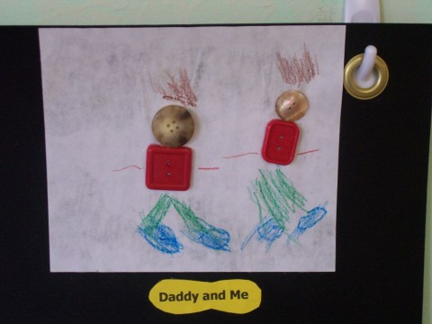
Button Shapes

Materials needed:
- A variety of buttons (The success of the activity depends on the
variety of button shapes provided for the children.)
- White glue
- White paper (best to use construction paper or cardstock)
- Crayons or markers

Who: Small groups

How to:
- Children choose buttons and glue them to the paper to make a picture.
- Children use crayons or markers to draw around the buttons.
- Adult asks children to describe their pictures and writes down what the children say.
- Use math prompts as suggested in the handout “How to Talk About Shapes.”

Teacher reflection: What are children learning as they participate in this activity?

Activity adapted from: Clements & Sarama 2007.

2-D Faces of 3-D Shapes Game

This game focuses on the parts and properties of shapes.

Materials needed:
- Food boxes and cans in different sizes (ensure that the containers are of similar shapes)
- Paper
- Marker or pencil

Who: Small groups (Teacher should note how each item is traced—square if it is flat vs. end of a box, which is a rectangle.)

How to:
The following occurred in one preschool:

Teacher: “Which circle did I get when I traced this can?”

Children: “The one in the middle!”

Abby was interested in the side of the can. She was surprised that she got a rectangle after tracing it. She looked at the can from the side, trying to see the rectangle.

- Food cans—bases are circles.
- Trace the can.
- Shuffle the papers and cans; children match cans to the circles traced.
- Shape hunt for circles.
- Repeat with boxes—rectangles.
Alternative activities:
- Pre-trace or cut out shapes and have children match the containers
with the cutouts.

Activity adapted from: Clements & Sarama 2007.

