Measurement Concepts | Literacy Area   | Outdoor Area  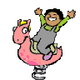 | Dramatic Play Area  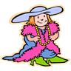 | Small toy Area  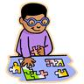 | Art Area   | Discovery Area  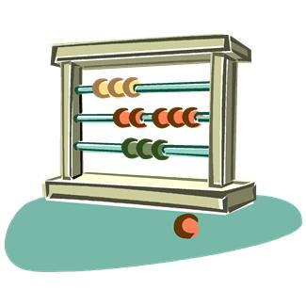 | Block Area  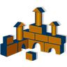
Comparing

Ordering

Measuring

Creating Invitations throughout the Environment
Read the measurement section and record your ideas for materials into the appropriate boxes.

