
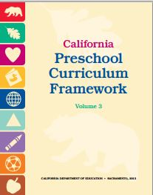
Science Domain
Guiding Principles
Handout 5

Guiding Principles | Page #  (PCF, Vol. 3) | Notes/Ideas
The preschool environment supports  children’s curiosity and encourages  inquiry and experimentation. | p. 138
Content of inquiry is developmentally appropriate and builds on children’s prior experiences. | p. 139
Scientific inquiry experiences are interesting and engaging for children and teachers. | p. 139 | l l
Children explore scientific concepts directly through active, hands-on, minds-on playful experiences. | p. 139
Children explore scientific concepts in depth through multiple, related learning experiences over time. | p. 140
Children construct knowledge through social interactions with peers and adults. | p. 140
Children use language and other forms of communication to express their thoughts, describe observations, and document their work. | p. 140
Teachers support children who are English learners in understanding and communicating scientific knowledge and skills. | p. 140
Science is embedded in children’s daily activities and play and provides a natural vehicle for integrating mathematics, literacy, and other content areas. | p. 141
Individual differences are recognized, and all children are included and supported. | p. 141
The preschool environment, home, and community are connected through science. | p. 141

