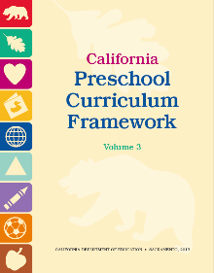

**Scientific Inquiry**

**(The following information can be found on pages 170-171 of the Preschool Curriculum Framework [Vol. 3].)**

**Types of Open-Ended Questions Example Questions**

|  |  |
| --- | --- |
| **Questions to encourage children to share their observations:** | * “What *did you notice* when you observed the snail?” * “What *happened* to the ice cube when we left it outside?”   •  • |
| **Questions to facilitate children’s problem-solving and investigations:** | * “What *do you think we could do* to make the ball roll down in this direction?” * “Can *you think of another way to* make the clay softer?” * “How *could we find out* what worms like to eat?"   •  • |
| **Questions to elicit children’s**  **predictions and explanations:** | * "Why *do you think* this plant grew and this one did not?” * “Why *do you think* the pill bug turned its body into a ball   shape?”   * “What *do you think* will happen if you mix salt with water?”   •  • |

“Having an adult encourage, prompt, and scaffold the use of expressive language in English and in the child’s home language whenever possible, would support the child’s overall development of scientific knowledge and language skills” (PCF, Vol. 3, p. 169).

|  |  |
| --- | --- |
| **Open-Ended Questions in English** | **Open-Ended Questions in Spanish** |
| * What does this make you think of? * In what ways are these different? * In what ways are they the same? * What materials did you use? * What would happen if…? * What might you try instead? | * ¿En qué te hace pensar esto? * ¿En qué maneras son estas diferentes? * ¿En qué maneras son estas iguales? * ¿Qué materiales usaste? * ¿Qué pasaría si…? * ¿Qué podrías intentar en vez de…? |