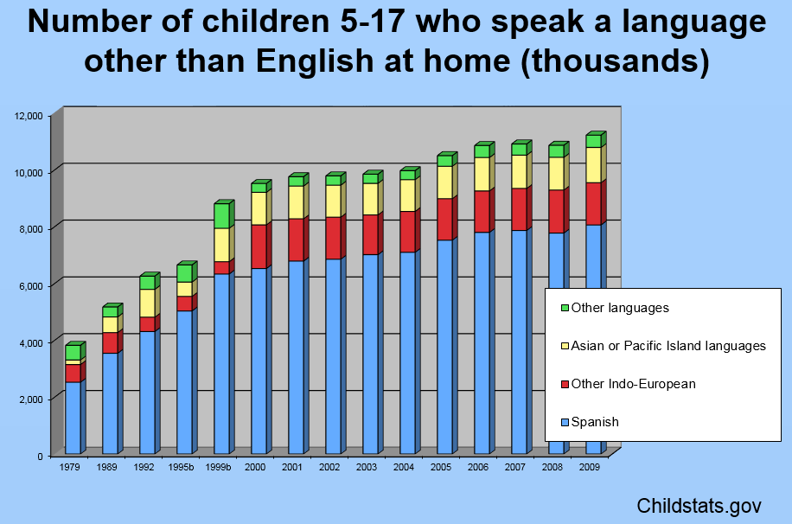

Based on the California Language Census from fall 2014, we know the following:

* There are more than one million ELs in TK-12.
* Nearly one quarter (22.3%) of total enrollment is comprised of ELs.
* More than 2.5 million students, or approximately 40% of students (English Learners and Fluent English Proficient), speak a language other than English in their homes.

The majority of English learners (73%) are enrolled in TK through sixth grade. English learner data is collected for 60 language groups; however, 94 percent speak one of the top ten languages in the state:

* Spanish 83.7%
* Vietnamese 2.3%
* Filipino (Filipino or Tagalog) 1.4%
* Mandarin (Putonghua) 1.4%
* Cantonese 1.3%
* Arabic 1.2%
* Hmong 0.9%
* Korean 0.8%
* Punjabi 0.7%
* Russian 0.6%

Source: CDE (2016). Facts about ELs in CA—CalEdFacts. Retrieved from <http://www.cde.ca.gov/ds/sd/cb/cefelfacts.asp>.