Physical Science Lab– Activity
Directions: 1. Print on cardstock 2. Cut on designated line
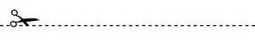

Force and Stability; Balance and Motion

Form and Function

Cause and Effect

Size, Weight, and Shape

Change in Objects and Materials

