
Activity 2: Build a Bridge

intent:
This activity is designed to cooperatively engage pairs as they follow a sequential pattern in the song. After the song, pairs discuss skills that young children would be learning by actively engaging in the song. This activity exemplifies Active Participation, the first substrand in the Active Physical Play strand.

OUTCOMES:
- Participants will actively engage and cooperatively move with a partner and by themselves throughout the song.
- Participants will connect skills in various domains that are engaged via the activity.
- Participants will increase their moderate to vigorous physical activity (MVPA) through active engagement.


Materials Required:

- Song: “Build a Bridge” by Angela Russ, on the Smart Moves 2 CD—it is highly recommended to download the song from the CPIN website and embed it directly into the PowerPoint
- Speaker/amplification system
- Optional: Use an MP3 player rather than embedding the song into the PowerPoint

Time:5 minutes

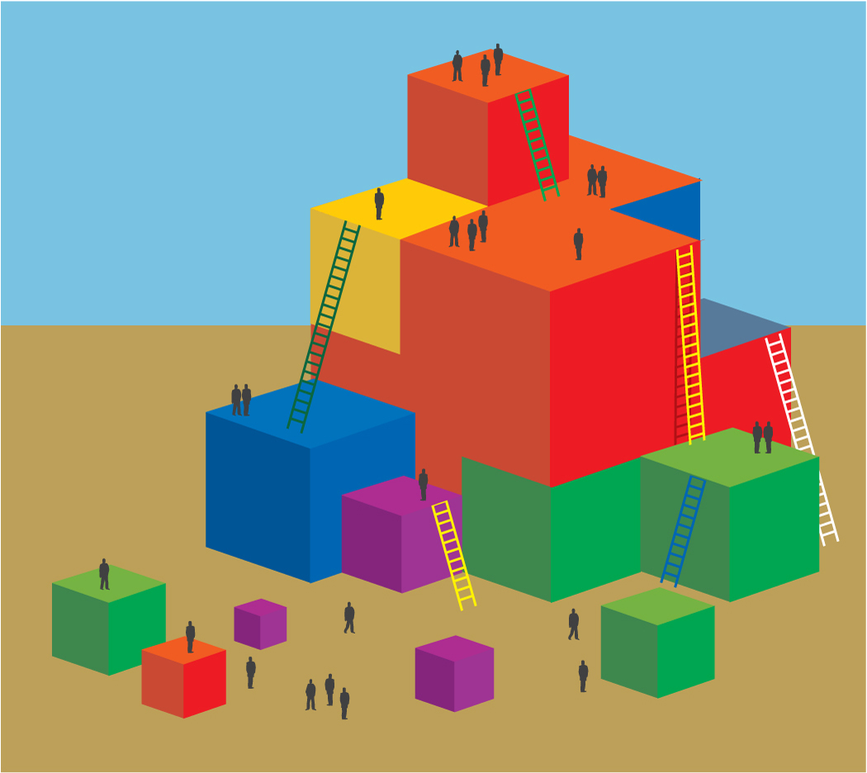
Process:
- Prepare participants for movement—check clothing and shoes and remind participants to move safely and within limitations.
- Have participants push in chairs at tables, along with bags/totes/etc.
- Invite participants to find a partner and stand facing their partners.
- Introduce all of the movements of the song to the audience (see lyrics and diagram at end of sheet) so everyone can practice first. Encourage everyone to say the words to the song for better retention (the song will be revisited at “warp speed” later in the training).
- Cue the music. The song is “Build a Bridge” by Angela Russ and is found on the Smart Moves 2 CD—visit http://www.AbridgeClub.com/ for lyrics and additional information.
- After the song, have pairs discuss what children would be learning by engaging in the song.

Lyrics:
With partner:
Build a bridge, build a tunnel, build a road. (2x)
Build a bridge, build a tunnel, build a bridge, build a tunnel,
Build a bridge, build a tunnel, build a road.

Individually:
Build a cave, build a tower, build a wall. (2x)
Build a cave, build a tower, build a cave, build a tower,
Build a cave, build a tower, build a wall.

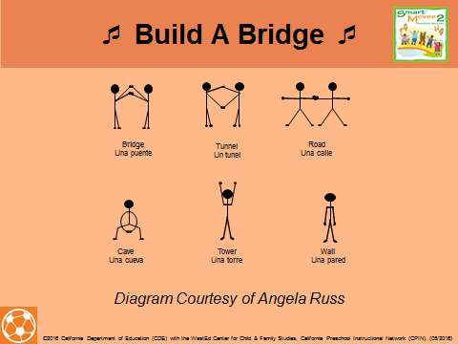

OPTIONS:
- If the time is limited, only do half of the song.
- If a participant does not have a partner, the trainer can invite the participant to be his or her partner in front of the group, or have a group problem-solve using a third person.
- For participants with physical restrictions, pairs can problem-solve new movements to represent each action.
- Ask each pair to share what they discussed that children would be learning by engaging in the song. Have the pairs try not to repeat what another pair has said—this keeps everyone mindful of all the responses.

