
Activity 2: Build a Bridge—Warp Speed

intent:
The activity is designed to illustrate how music and movement can greatly increase moderate to vigorous physical activity (MVPA). This activity exemplifies Cardiovascular Endurance, the second substrand in the Active Physical Play strand.

OUTCOMES:
- Participants will actively engage and cooperatively move with a partner and by themselves throughout the song.
- Participants will check their heart rate immediately after the song and make the connection that increased heart rate equals moderate to vigorous physical activity.

Materials Required:


- Song: “Build a Bridge—Warp Speed” by Angela Russ, on the Smart Moves 2 CD—it is highly recommended to download the song from the CPIN website and embed it directly into the PowerPoint
- Speaker/amplification system
- Optional: Use an MP3 player rather than embedding the song into the PowerPoint

Time: 5 minutes

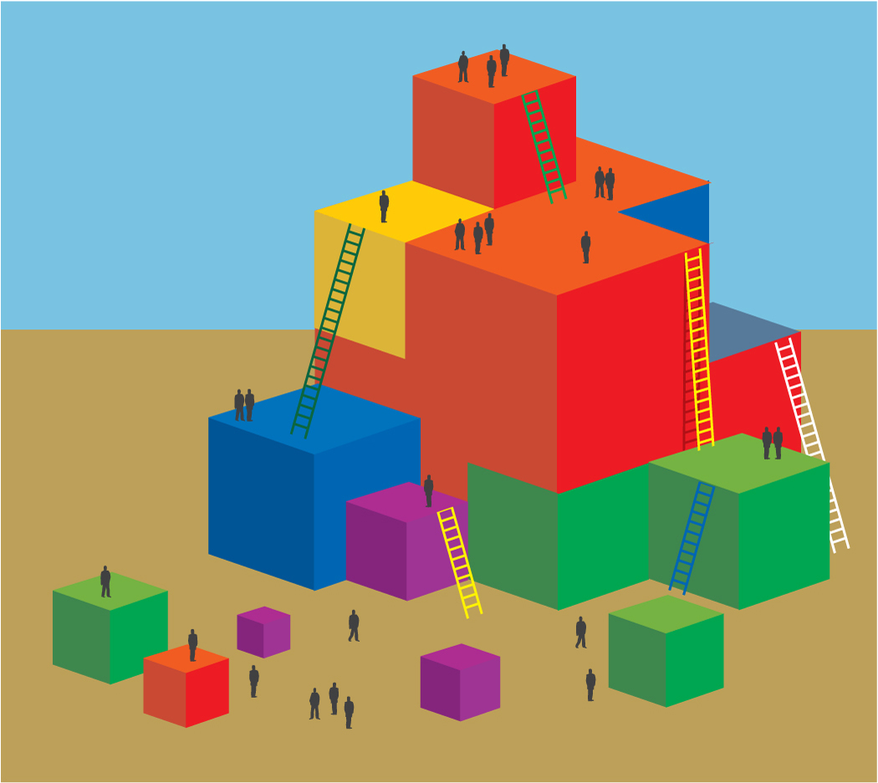
Process:
- Prepare participants for movement—check clothing and shoes and remind participants to move safely and within limitations.
- Have participants push in chairs at tables, along with bags/totes/etc.
- Invite participants to find a partner and stand facing their partners.
- Inform participants that this is the same song that they previously performed, but at “warp speed.” There are no words to the song, so everyone needs to sing. The song will get faster and faster. See the end of this sheet for lyrics and movements of the song.
- Cue the music. The song is “Build a Bridge—Warp Speed” by Angela Russ and is found on the Smart Moves 2 CD—visit http://www.AbridgeClub.com/ for lyrics and additional information.
- Immediately after the song, have everyone check their heart rate. The majority of people should be able to identify an increased heart rate. Congratulate everyone on attaining moderate to vigorous physical activity (MVPA)!
- Music is an easy way to accumulate minutes of moderate to vigorous physical activity—share this message with families too.

Lyrics:
With partner:
Build a bridge, build a tunnel, build a road. (2x)
Build a bridge, build a tunnel, build a bridge, build a tunnel,
Build a bridge, build a tunnel, build a road.

Individually:
Build a cave, build a tower, build a wall. (2x)
Build a cave, build a tower, build a cave, build a tower,
Build a cave, build a tower, build a wall.

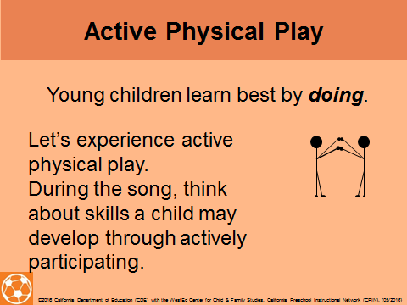

OPTIONS:
- If the time is limited or the fitness of the group is extremely low, only do half of the song.
- If a participant does not have a partner, the trainer can invite the participant to be his or her partner in front of the group, or have a group problem-solve using a third person.
- Pairs can discuss activities that they do in their everyday routine and that provide them with moderate and/or vigorous physical activity.

