
Activity 3: Substrand Reflection Interactions and Strategies (for 1.0, 2.0, and 3.0)

intent:
This activity is intended for participants to use a physically active technique to review and apply interactions and strategies for each substrand,

OUTCOMES:
- Discuss each substrand reflection with a partner while engaging in physical activity that is relevant to the substrand.
- Acquire a new strategy to share with other staff and/or families.



Materials Required:
- Participant folders
- Handout 8: Substrand Reflection Interactions and Strategies

Time: 2–3 minutes for each substrand reflection

Process:
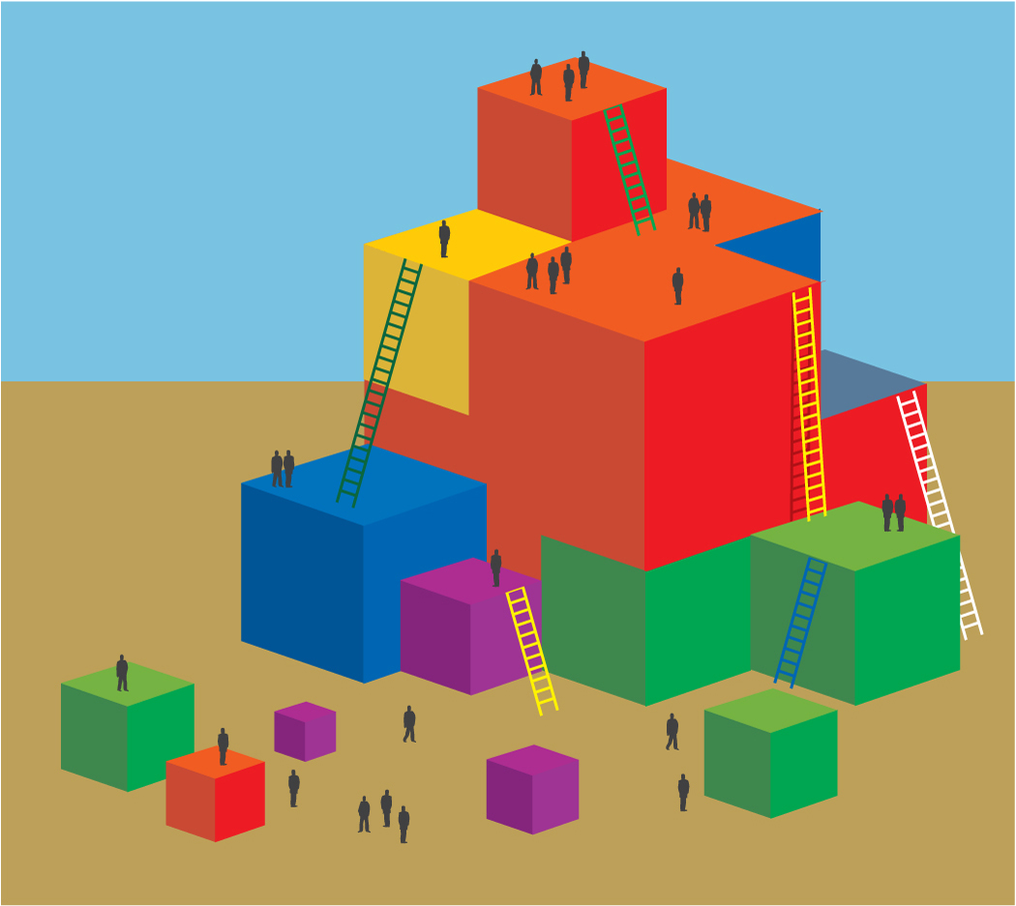
- At the appropriate place in the training PPT, each substrand reflection slide indicates how partners will engage in physical activity while discussing the interactions and strategies for the identified substrand. Remind participants to move safely, be aware of others and objects around them, and honor physical restrictions or limitations.
- The substrand 1.0 activity is Walk and Talk. Walking and talking illustrates the substrand of Active Participation.
- The substrand 2.0 activity is to March and Talk. Marching quickly and talking illustrates the substrand of Cardiovascular Endurance.
- The substrand 3.0 activity is to Sit and Stretch. Sitting and stretching illustrates the substrand of Muscular Strength, Muscular Endurance, and Flexibility.

OPTIONS:
- Participants create new movement strategies rather than the ones listed.

