
Activity 4: Yoga

intent:
This activity is designed to engage the participants in three basic yoga poses from the Shape of Yoga document that illustrates muscular strength, muscular endurance, and flexibility.

OUTCOMES:
Participants practice three yoga poses by holding poses and breathing and experience how to engage muscles.

Materials Required:

- Shape of Yoga document (printed in English and Spanish), available at https://www.cdph.ca.gov/programs/cpns/Documents/Network-ShapeofYoga.pdf

- PowerPoint slides containing illustrations of poses for the audience to view
- Ample space for each participant to partake in poses free of obstacles

Time: 7–10 minutes

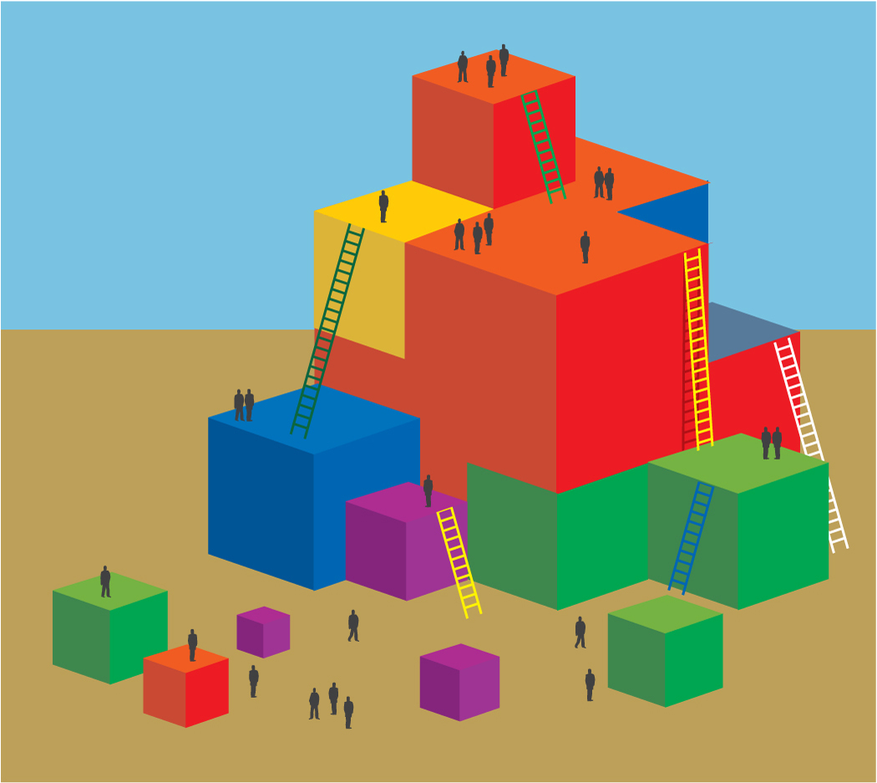
Process:
- Prepare participants for movement—check clothing and shoes and push in chairs at tables, along with bags/totes/etc.
- Prompt participants to stand and find an area that has ample space and is free of obstacles. Invite all participants to partake in three yoga poses.
- Introduce each pose. (See the next page for instructions on each pose.) Remind participants to take their time as they work through each yoga pose and to move within limitations.

OPTIONS:
- Ask participants to hold onto chairs if needed for balance.
- Encourage participants with physical restrictions or limitations to modify the poses to meet their needs, or to relax and take the time to focus on their breathing, clearing their mind of thoughts.
- Many yoga programs are available for children. If your resource library includes such programs, feel free to share them with the audience.

YOGA POSES:
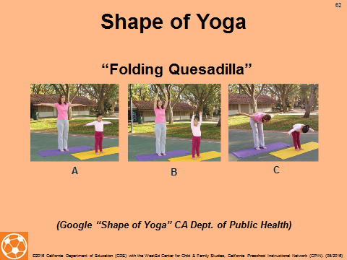
Folding Quesadilla:
1. Stand tall with your feet slightly apart (A).
2. Breathe in, raising your arms out to your sides (A).
3. Hold for two breaths (A).
4. Breathe in again as you look up and reach for the sky (B).
5. Breathe out, sweep your arms back down to your sides,
and bend at the waist, toward your knees (C).
6. Return to the start position (A).

Ask the audience where they feel the stretch in their body. Breathing into the stretch sends oxygen to the muscles, enabling them to perform better.

Broccoli Lunge:
1. Stand with your feet wide apart (A).
2. Turn your right foot out to the side (B).
3. Breathe in and raise your arms out to your sides,
like the branches of strong, sprouting broccoli (B).
- Breathe out, look over your right hand, then bend
your right knee to lower yourself into a “lunge” (C).
5. Hold this position for two breaths, strong like a fresh, green broccoli stalk (C).
6. Straighten your knees and return to the starting position (A).
7. Switch sides and repeat.

During the holding pose, ask the audience how their muscles feel as they work hard to hold the pose. Yoga is a great activity to strengthen muscles and increase muscular endurance. A little yoga every day will tone one’s body.

Apple Tree:
1. Stand tall and strong, like a healthy apple tree (A).
2. When your legs are deeply rooted and balanced,
breathe in and raise your arms out to your sides,
like the branches of an apple tree (A).
3. Lift your right leg and place your right foot on the inner
part of your left leg (B).
4. Hold for two breaths.
5. Raise your arms higher and wiggle your fingers, like leaves on an apple tree (C).
6. Breathe out and slowly return to the start position (A).
7. Switch sides and repeat.

During the balance pose, ask the audience if they can feel messages being transmitted from their muscles to their brain, telling their brain how their body is balancing. Muscles and the brain communicate to each other all the time, effortlessly. Balance is a good skill for all ages, young and old—the young need to practice balance so that they become more coordinated, and older folks need balance to prevent falls.

