
Activity 5: Homemade Streamer

intent:
This activity, the culminating activity for the Active Physical Play strand, is designed to engage cooperative planning among tables, utilizing a homemade prop (streamer) to create an age-appropriate station activity.

OUTCOMES:
- Participants assemble a homemade streamer that can be used to increase physical activity and connect to content areas through active physical play.
- Participants are able to share ideas and directions with teachers, early childhood educators, and families to increase physical activity in young children.


Materials Required:

- 5’ satin ribbon, 1/participant
- Gripper stamps, 1/participant
- Scissors
- Sandwich bags, 1/participant

Time: 3–5 minutes


Process:
- Prior to training, ribbon and gripper stamps need to be purchased (see the next page for ordering info, or refer to Handout 10).
- Cut the ribbon into 5’ lengths.
- Place each ribbon and a gripper stamp of a matching color into a separate sandwich bag. The bags will be placed on tables at the beginning of the training.
- To make the streamers, wrap the ribbon to the gripper stamp and secure it with two or three knots. See Handout 10: How to Make Homemade Streamer Directions and Information for step-by-step directions.

OPTIONS:
- Substitute hair ties in lieu of gripper stamps.
- A variety of colored crepe paper may be used if the budget is restricted or if time is limited.

Make It Take It Supply Information
OrientalTrading.com
http://www.orientaltrading.com/

Allow 2–3 weeks for ordering and delivery

Prep time: 30 minutes

Each participant needs one ribbon (cut into 5’ lengths)
and one gripper stamp

Place items in a sandwich bag

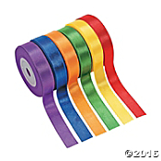 | Super Sensational Ribbons  IN-57/9084  $7.50/set (1 set) or $6.99/set (3 or more sets)  (6 pcs. per set) 1/2" x 10 yds.  http://www.orientaltrading.com/super-sensational-ribbons-a2-57_9084.fltr?prodCatId=552705
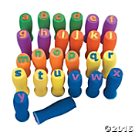 | Easy to Grip Lowercase ABC Stamps  IN-56/2330  $14.99/set  (26 pcs. per set) 1" © OTC  http://www.orientaltrading.com/easy-to-grip-lowercase-abc-stamps-a2-56_2330.fltr

