Two Truths and a Myth | 
 | intent:  Apply knowledge gained about the foundations to the task of separating facts from myths.

OUTCOMES:

Participants will apply critical knowledge to decipher true and false statements about key ELD concepts.

 | Materials Required:  - PPT slide    - Handout 2: Two Truths and a Myth  - “Hello” language cards (in various languages) on tabletops  - PLF (Vol. 1) for reference  TIME: 25 minutes
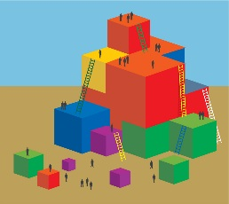 | Process:  Direct participants to:  - Find Handout 2: Two Truths and a Myth.  - Choose a “Hello” language card from the middle of the table.  - Seek out someone with the same “Hello” language card (this is your partner).  - Work through the handout with your partner.  - Return to table groups with completed handout.  - Compare handout answers with groupmates and come to a consensus. We will go over the correct answers when all table groups are ready.  Debrief options:  - Ask volunteers to bravely share-out answers; then ask for input on why they think their answers are correct.  - Use the trainer tool to offer suggestions on where participants can look for more information on these topics.  - Site some of the research sound bites from the trainer tool.

