Focused Video Viewing | 
 | intent:  Apply understanding of the foundations while viewing and reflecting upon a video.

OUTCOMES:

Participants will look for, identify, discuss, and reflect upon the unique differences between the levels of beginning, middle, and later as viewed in the Listening and Speaking strand foundations video.

 | Materials Required:  - PPT slide  - Partners/Tablemates    - Preschool Learning Foundations (Vol. 1). pp. 107-108  - Foundations Video Library: Listening and Speaking  strand 48 or 60 months  - Table tents for each table labeled either Beginning, Middle, or Later  TIME: 25 minutes
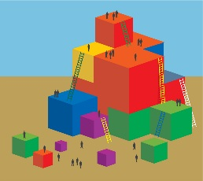 | Process:  - Ask participants to turn to pages 107 and 108 of the Preschool Learning Foundations (Vol. 1). Participants read the level descriptions for beginning, middle, and later and notice the developmental shifts between those stages.  - Explain that participants will take a closer look at the foundations for the Listening and Speaking strand as well as watch a video exemplifying the three levels for at least two foundations.  - Have each table group identify the level on their table tent (beginning, middle, or later); they will be responsible for noting the hallmarks of that level showcased in the video. They should be prepared to share-out. (Optional - Write key points on chart paper.)  - Ask groups to come to a consensus on what key points and types of skills were illustrated in the video for their level. They should be prepared to share-out.  DEBRIEF:  Invite participants to highlight the similarities and differences between the levels they noticed in the video, as well any key “aha” moments.

