Using Comprehension Skills





**intent:**

Reflect on a personal experience that involved reading comprehension skills.

**OUTCOMES:**

Participants will discuss the skills involved in reading comprehension and reflect on daily activities that involve reading comprehension.

MCBS00539A0000[1]Dancing Clock

**Materials Required:**

* Reading picture/story cards

**Time:** 10 minutes

**Process:**

* Invite groups to explore the reading picture/story cards on the table.
* 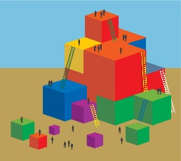Ask participants to choose the card that they most relate to. (It can be the picture they like best, or the picture that depicts the reading experience they use most frequently.)
* Have participants look at the picture/story cards that they chose as they use the following questions to prompt discussion regarding reading comprehension within their table groups. Allow 5 minutes for discussion.
* Is comprehension taking place in the picture? If so, how is it occurring, and what skills are being used?
* When was the last time you had a similar experience?
* What comprehension and analysis skills did you use?
* What experiences do you remember as a small child that may have laid the groundwork for those skills?
* Bring participants back together as a large group and debrief by holding up each picture/story card and asking participants to stand up when they see the card they chose.
* Debrief—The following are possible questions and prompts to use during the debriefing as presenters best see fit:
  + Which cards are more popular? Why might that be?
  + Which specific comprehension skills are used frequently?
  + What emotions correlate to the pictures?
  + What personal meaning do some of these pictures have?

MCj02958800000[1]

**OPTIONS:**

* Instead of allowing participants to choose the picture/story card they most connect with, pass out the cards and tell them to find a partner with the same card. Then follow the directions above.
* Post pictures/story cards around the room on chart paper and have participants walk around the room, choosing which card they want to stand by. Then complete the activity with the groups that have formed around the room.