 What Do You Remember? (Share and Compare)



**intent:**

Use listening and speaking skills while greeting and sharing ELD experiences that connect the content of the day to personal life experiences.

**OUTCOMES:**

Participants recall a reading experience, share that recollection with a partner, and compare their experience to the Reading substrands.



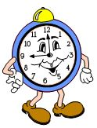**Materials Required:**

* PowerPoint slide
* Tablemates/Partners
* Literacy Memory Cards (printed on card stock and cut apart)

**Time:** 10 minutes

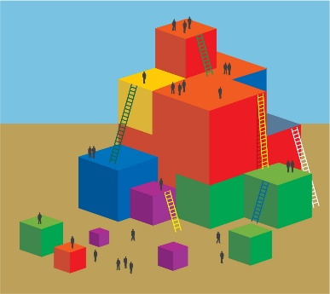

**Process:**

Prepare the Literacy Memory Cards and place them on the registration table for participants to look through and pick up as they walk into the room.

**DURING TRANING**

* Ask participants to choose a card that sparks a personal memory.
* Explain that the cards are marked with various literacy experiences that may relate to different reading skills.
* Say to participants, “As we are focusing on the ELD Reading strand today, we will start by discussing our personal experiences as we settle in to begin the day.”
* Ask participants to find someone who chose the same card as they did and to exchange their memories with this partner. (Allow at least five minutes for exchange; wait for conversation to slow before moving on.)
* Remind participants to discuss how the memory makes them feel, who is included in the memory, and why the memory is special to them.