 Examining Developmental Level Differences



**intent:**

Observe, discuss, and reflect upon the development occurring between the levels of beginning, middle, and later and make connections to the California Content Standards using the alignment document.

**OUTCOMES:**

Participants view foundations videos and identify specific difference between the developmental levels of beginning, middle, and later.



**Materials Required:**

* PowerPoint slide
* Groupmates
* Foundations videos (Trainer choice: two focus foundations)
* Preschool Curriculum Framework (Volume 1)
* Alignment Document
* DRDP-K (2015)
* Chart paper titled with either Beginning, Middle, or Later at the top of the T-chart and three columns labeled Foundations, CA Content Standards, and DRDP-K (2015)
* Markers
* 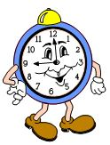Sensory materials for each table
* Letters “B,” “M,” and “L” for each table
* Tupperware container to hold sensory materials and letters

**Time:** 15 minutes

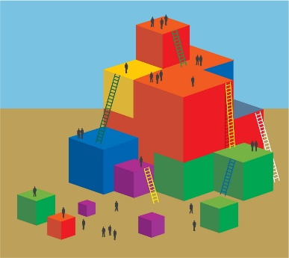

**Process:**

* Prepare chart paper for each group with either Beginning, Middle, or Later as the title at the top of a chart.
* Make as many charts as you wish to have groups (2-4 participants per group—depending on size of training).
* Place a small Tupperware of sensory materials on each table. Fill Tupperware with sand, feed corn, soft puff balls, or any other sensory objects of your choosing. These containers also need to hold the letters B, M, and L for each group. Letters can be made of foam, paper, magnets, or wood.

**Step 1:**

Ask participants to choose a letter from the sensory bin on their table, then have them find the chart paper that matches the first sound of their letter (B-beginning, M-middle, L-later).

**Step 2**

* Explain that the whole group will watch videos exemplifying the three levels for at least two foundations. Individuals will be responsible for noting the hallmarks of their chosen level as showcased in the video.
* Play the foundations example video while participants take notes.

**Step 3: CREATE CHART AND LEARN FROM EACH OTHER**

* Following the videos, individuals will find their chart paper labeled with B, M or L.
* With their group, participants should fill in the chart the important differences or unique key points about their developmental level that were illustrated in the videos for their level.
* At the bottom of their chart, invite participants to write anecdotal notes about children they have in their classrooms that make them think of this level in the English-language development continuum.
* Then invite participants to walk around the room and take photos or read and discuss the other charts.
* Once all participants are done reading the other groups work, invite them to sit back down at their original table groups and share any highlights or interesting facts they learned from this activity.

**DEBRIEF POINTS:**

* Remind participants that the levels of the foundations are not expectations to be used as competencies but rather the continuum provides a framework for teachers to better understand children’s English-language development.

BONUS: Are there any thoughts about how we broke up into groups by using the sensory bins and letters? How might you use something like this with your students**?**