Making Foundations Examples



**intent:**

Provide an opportunity to read over the foundations, reflect, and create examples.

**OUTCOMES:**

Participants will create examples that can be utilized as reflection tools.

MCBS00539A0000[1]**Materials Required:**

* Dancing ClockHandout 1: PLF Map Comprehensions and Notes Page
* Highlighters
* Pens and markers

**Time:** 15 minutes

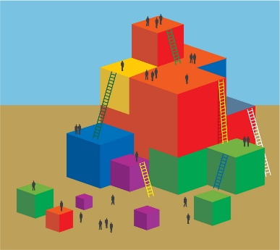

**Process:**

**Step 1:**

* Instruct participants to read Handout 1: PLF Map Comprehensions and Notes Page and to focus on the foundation examples. Ask participants to play close attention to the developmental shift that is occurring between 48 months and 60 months.
* Direct participants to circle any examples that they have experienced in their classrooms. Then have them document the examples on the Notes Page of the handout (first column).
* Encourage participants to talk with their tablemates as they work.

**Step 2:**

* + Ask participants to think about the story they just heard.
  + Direct participants to create an example for 48 months and for 60 months that they could imagine observing in a child who had experienced the same story. Have them document their examples on the Notes Page of the handout (second column).

**Step 3:**

* + Ask participants to pair up with someone wearing a different character label than themselves and to share their examples with them.

**Step 4:**

* + Ask participants to again think about the story they just heard.
  + Have participants think of a child in their classroom who is just advancing beyond the 60-month foundation.
  + Direct participants to write an example they could imagine observing in this child after they had experienced the same story with similar opportunities. Have them document their example on the Notes Page of the handout (second column).
  + Have participants write a strategy they could plan to use to support this child on the Notes Page of the handout (third column).

**Step 5:**

* + Ask participants to pair up with a new partner—again, someone wearing a different character label than themselves—and to share their example with them.
  + Bring the whole group back together and have them share-out any “aha” moments.