 Unpacking the ELD Reading Foundations



**intent:**

Use the developmental levels of the ELD reading foundations to reflect upon and plan for different development progressions.

**OUTCOMES:**

Participants reflect on a bag story and incorporate details of the ELD reading foundations into scaffolding for different developmental levels and gathering evidence for the DRDP-K (2015).

**Materials Required:**

* PowerPoint slide
* 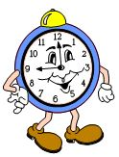Partners/tablemates
* Foundations pages (maps)
* Chart paper with three questions (below) and space to write answers.

**TIME**: 20 minutes (expanded over several slides)

**Process:**

* 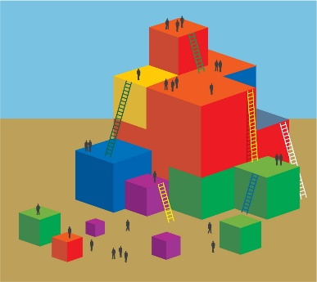Ask participants to turn to page 123 in the Preschool Learning Foundations and choose one foundation to focus on with their tablemates. (Handout 1b may be used if not everyone has a table copy of the foundations.)
* Walk participants through the process of using a focused conversation to think about what the teacher’s role is in supporting the achievement of ELD students in the Reading strand.
* Trainer’s example:
  + Let’s look at page 123 of the Preschool Learning Foundations (Reading 1.0: Children demonstrate an appreciation and enjoyment of reading and literature. *Focus: Participate in read-aloud activity*)
  + Read the beginning level foundation to yourself.
  + Let’s answer the following questions as a group:

1. What is the progression of behavior, knowledge, and skills across the levels of the foundation?   
   Answer) *Example: Attending—to English or home language*
2. What key words jump out at you?   
   Answer) *Example: Home language, storybook*

What opportunities does a child need to make progress in acquiring the knowledge skills and abilities for this foundation? Answer) *Example: Opportunities to hear storybooks in home language*