Being Prepared: Finding the Evidence





**intent:**

Become familiar with one way to use vignettes to enhance teaching.

**OUTCOMES:**

Participants will read a vignette from the Preschool Curriculum Framework (PCF) and analyze that information in relation to their personal planning practices.

MCBS00539A0000[1]Dancing Clock

**Materials Required:**

* Preschool Curriculum Framework, Volume 1, p. 147
* Sticky notes
* Sticky Wall or Handout 4: Finding the Evidence

**Time:** 15 minutes

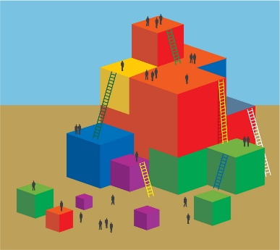

**Process:**

* Guide participants to read page 147 in the Preschool Curriculum Framework.
* Ask participants to identify how the teacher planned ahead to increase story comprehension, jotting down the methods the teacher utilized on the sticky notes. Tell them their notes will be shared with the group.
* Allow 10 minutes for reading and note taking.
* After participants have finished, have them place their notes on the Sticky Wall or on Handout 4: Finding the Evidence.
* Debrief:
  + Guide participant’s attention to the ways the teacher planned for story comprehension.
  + Have participants identify a planning method that they already use to increase story comprehension.
  + Have participants identify a planning method they will implement to increase story comprehension.

**OPTIONS:**

* MCj02958800000[1]If presenters are using a Sticky Wall, debriefing can be done as one large group or with individual table groups.
* The columns on Handout 4: Finding the Evidence can be separated on chart paper and hung around the room so that participants can walk around to place their sticky notes.