 Board Games

**intent:**

Gain experience with reading concepts by playing and creating personalized games for students to practice reading concepts in the classroom.

**OUTCOMES:**

Participants play and create reading concept games and discuss how these games could be used in the classroom to focus on children’s needs and strengths.



**Materials Required:**

* PowerPoint slide
* Handout 6: Board Games
* Game materials (see Table Materials 2: Game Pieces: Grandma’s Bag Photos)
* 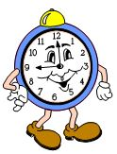Board game materials for “make and take” for each participant (large foam cardboard, four pawns, brown bag, printed book icons, dice or spinner)
* Chart paper labeled with questions (below).

**TIME**: 30 minutes

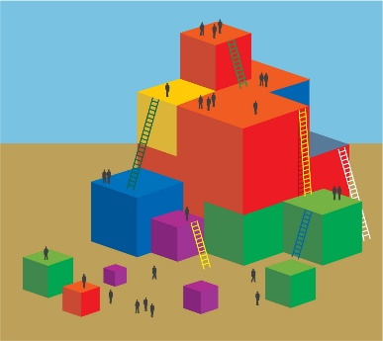

**Process:**

* Prepare board game materials (“make and take”) for each participant.
* Prepare chart paper for each group with questions listed above.

**BOARD GAME**

* Hand out board game materials for make and take and say:
  + Think back to the bag story.
  + How could you build on that activity and focus on one of the substrands we highlighted? One idea is to create a board game.
  + Find the board game handout and glance over it. Let’s do this together. (Demo the Grandma’s Bag Board Game and share materials with participants for make and take.)

**CHART YOUR REFLECTIONS**

* Say to participants, “Once you have finished your game, work with your tablemates to chart your reflections and answer the following questions>”
* What foundations does your game support?
* What CA Content standards is it leading up to?
* How will you individualize for students with your game?
* What other domains are integrated within the ELD experience offered through your game?
* Walk around the room and look at the other charts.