Environment Map





**intent:**

Read and brainstorm about how to enhance story re-telling skills.

**OUTCOMES:**

Participants will create a map with examples, share ideas, and use the ideas gathered as resources to support them during story re-telling time in their classrooms.

MCBS00539A0000[1]

**Materials Required:**

* Storytelling books
* Handout 5: Environment Strategies
* Dancing ClockHandout 6: Environment Maps
* Pens and markers

**Time:** 15 minutes

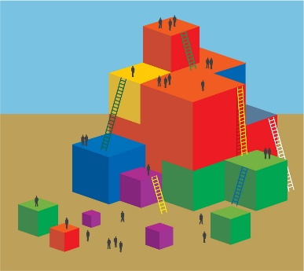

**Process:**

**Part 1:** (Each table has a different book at the center that will be used as their focus book.)

* + - Find Handout 5: Environment Strategies and Handout 6: Environment Maps.
    - Read the handouts and brainstorm with your table group about what could be added to the environment to support re-telling of this story in your classroom.
    - Complete at least one written map to share with other table groups.

**Part 2:**

* When the soft music starts, leave your groups’ completed map face up on your table.
* Visit other tables and look at the books and completed table maps left out by the other groups.
* Feel free to take photos or notes to document any interesting ideas you might want to replicate.

**REFLECTION:**

* What new strategies will you use during story re-telling time?
* How will these strategies enhance your classroom during story re-telling time?
* What prior knowledge will you continue to utilize to support you during story re-telling time?